South Metropolitan TAFE

Munster Campus

Applied Engineering

AGV Mecanum Platform

P

Advanced Diploma in Engineering - Mechanical

|  |  |  |  |
| --- | --- | --- | --- |
|  | Author | Student Number (I.D) | Date |
| 1. | Bryce Richards | P136265 |  |
| 2. | Robert Williams | P445885 |  |
| 3. | Cyprian Sino | P241310 |  |
| 4. | Gurkaran Singh | M234676 |  |
| 5. | Purnima Samararatne | M227958 |  |
| 6. | Zixiao Tang | M234547 |  |
| 7. |  |  |  |

## Abstract

Written by Gurkaran Singh.

The report documents the design project of the AGV Mecanum Platform to be made at South Metropolitan TAFE. The platform is an autonomous vehicle which will be capable to lift the lab equipment and relocate it within the set perimeter. The platform capable of lifting 1 tonne uses bolt screws connected to a motor to lift the platform and has four Mecanum wheels which are independently controlled by four electric motors, giving the AGV an ability to move in any direction without turning the wheels.

The design process involved individual team members working in tandem to produce a final collaborative product. One team member worked on the wheel, another on the chassis, lifting mechanism, etc.

The project was concluded with a final mechanical design which was partially prototyped.

Table of Contents

Abstract 2

Introduction 4

AGV Platforms 4

Design Concept 5

Problems associated with the design 5

Design Components & Material Selection 7

Mecanum Wheel 7

Frame 22

Lifting Mechanisms 26

Drive System 28

Control System 38

Calculations 41

Costings 45

Discussion and Conclusion 46

Recommendations 47

References 47

List of Figures 47

Appendix 49

## Introduction

Written by Bryce Richards.

In the manufacturing industry the use of automation is growing, especially in the world’s industrialised societies. This is largely due to the ever-increasing labour cost in these areas of the world. Equipment components are typically referred to as ‘automated’ because they perform their operations with a reduced level of human participation compared with the corresponding manual process. In some highly automated systems, there is virtually no human participation.[1]

Common benefits of industrial automation include:

* Increased labour productivity
* Reduced labour cost
* Mitigated effects of labour shortages
* Reduction/elimination of routine manual and clerical tasks
* Improved worker safety
* Improved product quality
* Reduced manufacturing lead time
* Accomplishment of processes that cannot be done manually
* Competitive advantage

The purpose of this report is to detail the collaborative design project performed at South Metropolitan TAFE over the 2017-2018 period. This project was focused on design of an AGV platform for use on campus. The report will describe what AGV Platforms are, the design concept for the project, design problems and their solutions, and the design process itself. It will finish with a discussion of the final state of the project and recommendations for future work.

## AGV Platforms

Written by Bryce Richards.

AGV platforms are a branch of automatically guided vehicles commonly used in industrial environments. These platforms are typically rectangular, and have an integrated lifting mechanism used for ‘work-in-process’ movements. Work-in-Process movement is an application wherein AGV’s can be used to move material from the warehouse to production/processing lines or from one process to another.[2] A typical AGV platform is rated for a low maximum payload relative to its size, is powered electrically via on-board batteries, and with prices ranging up to $30,000USD for units capable of lifting 500kg.[3]

## Design Concept

Written by Bryce Richards.

The Mecanum AGV will be capable of automatically transporting a lab from the storage room to the fluids laboratory, or from the fluids laboratory to the storage room. There will be a number of specified pickup and set-down locations in each room. A user will select a ‘From’ and ‘To’ location and the Mecanum AGV will transport the lab accordingly.

Design criteria were as follows:

* Maximum dimensions will be 795mm(W) x 800mm(L) x 250mm (H)
* Maximum rated capacity of the Mecanum AGV will be 1000kg
* Maximum speed of the Mecanum AGV will be 3kmph
* The maximum exposed incline on which the Mecanum AGV will operate will be 1°
* The maximum lift height of the Mecanum AGV will be 100mm
* The location Mecanum AGV will be accurate to +/-25mm

All technical drawings will be to AS1100.

## Problems associated with the design

Written by Bryce Richards and Robert Williams.

Client amendments were a major problem during the project. These were difficult to manage as the original project team did not develop a formal scope document or Gantt chart. These changes included:

* Change to maximum payload from 500kg up to 1000kg
* Changes in scope to the operating environment of the AGV
* Late addition of IP65 requirement (waterproofing)

Lack of administrative project management was a problem. As above, the original project team did not develop a formal scope document or Gantt chart. These were developed in the 16th week of the project, at which point these were developed and rolled out.

An issue associated with the design was the choice of the initial lifting system. Initially a pneumatic lifting system was chosen, this consisted of an airbag with an on-board compressor. This options was chosen for its ease in installation and maintenance, its high capacity and cost compared to other systems. The airbag recommended by the supplier for our purpose is shown in FIGURE A. On further discussion with Michael Wernik a price of $397 for the airbag and $348 for the compressor. There is no official quote from this supplier as it was received over the phone, but the email correspondence is shown in FIGURE K.

The issue that arose with this system was learning from the supplier that an on board receiver would be require as the compressor would not be capable of sustaining the lift, as the volume of the airbag at 100psi and full lifting height is 4 litres, a receiver with an 8 litre capacity was required, as the compressor could only be used for filling the receiver. This was an issue as the client scope was to fit through a standard door frame, meaning the maximum length and width could not exceed 1000mm x 800. The Supplier sent through receivers shown in FIGURE L. On further inspection of this it was found that it was not possible to fit a receiver and keep within the scope size limits. For this all options were exhausted, one option was to use the SHS as a receiver but this was deemed unfeasible due to the cost of pressure testing and the complex welding involved. This then resulted in a redesign of the lifting mechanism, as the implementation cost of the pneumatic lifting mechanism outweighed the cost of a redesign.

## Design Components & Material Selection

### Mecanum Wheel

Rollers

Roller designed by Robert Williams

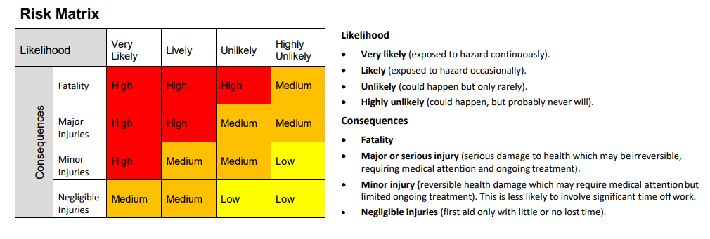One of the first tasks on this project was to design the Mecanum Wheel, one major part of this design was the individual rollers as this can have a huge effect on the stability of the vehicle. If the mecanum wheel is not a complete total circle it can cause a rough and bouncy drive. Due to the fact that in the initial scope the vehicle was to lift 500kg and then increase to 1000kg, the even drive of the vehicle was a major concern as the instability of the load would pose a risk to pedestrians. A Risk matrix in figure was used to analyse the risk of an uneven drive, form the matrix below it was deemed the risk of an uneven drive was deemed as a medium risk due to the maximum lifting height being a maximum of 80mm, to ensure safety the wheel was designed to minimise this risk.

Figure 1.1 Risk Matrix

[4]

Initially using a standard ellipse in the design of the roller incurred problems as the gap in the roller was deemed to be too large and would cause issues with the stability of the vehicle. Through further research a method shown in FIGURE M,[5] with some trial calculations shown in the calculation section this method was inconclusive. Another method trialled was the use of AutoCAD and geometry to calculate the angel curvature of the ellipse and give a full shape of the roller, this method is shown in FIGURE N. This method proved most successful and was the chosen design strategy as it gave minimal spacing between rollers. Figure 1.3 shows the assembled mecanum wheel.

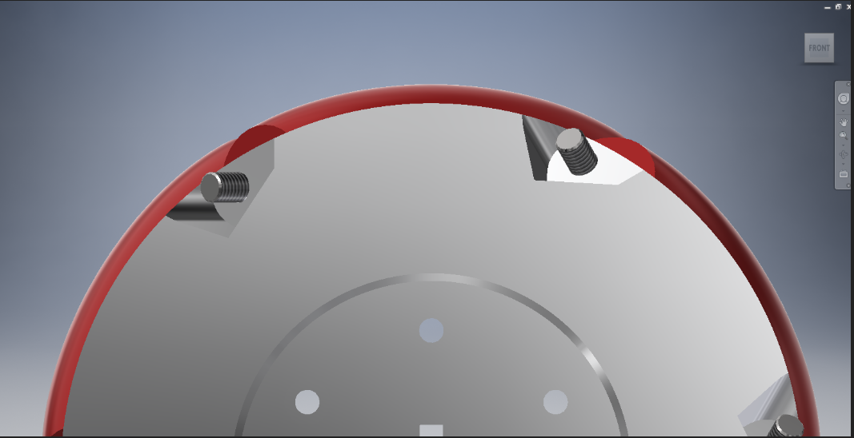

Figure 1.3 Mecanum Wheel assembly

One factor that was required by the client was to keep the number of rollers to a minimum of 6, this was required to keep manufacturing costs to a minimum. This impacted the design of the roller as the size and shape of the roller had an effect on the number of rollers in contact with the ground at any one time. Looking at off the shelf products, it is shown to have a higher number of rollers to ensure a larger contact area and a smooth drive.

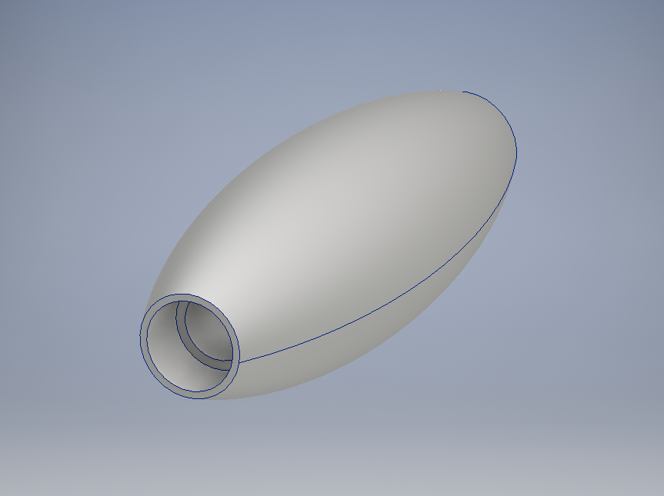With the designed shape of the roller bearing selection is important as the outer diameter is ᴓ22mm and a 3mm gap between the bearing and the outer diameter is required. This gives a maximum ᴓ19mm bearing size. The shaft diameter is 8mm, the bearing selection is shown in the calculations section. The calculation shown is for the initial scope of 500kg. The bearing selected shown in the FIGURE O is rated to handle the load capacity NSK bearing 698 ZZ was selected, the scope was then changed by the client to 1000kg. The increased capacity created a problem as the bearings selected are not capable of handling the load required. One solution to this was to redesign the roller but quotes were obtained from State wide bearings and BSC to have the unit price of the bearings, $4.50 + GST was the best price received. It was decided to then add 2 more bearings to each roller, 4 in total as there is no available bearing that matches the require criteria. Since the additional cost of the bearings are cheaper than the cost of a total roller redesign. The final roller drawing, and design is shown in the FIGURE P. Aluminium 6061 was the best material to use as it is lighter and cheaper than steel and has a UTS of 300 MPa[6].

Figure 1.4 Final Roller Design

Polyurethane

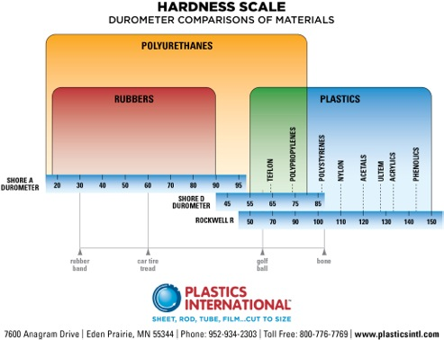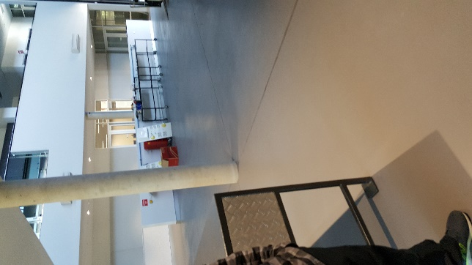The main working area for the AGV is a concrete floor shown in figure 2.1, it shows a concrete floor. As the friction between the concrete and the aluminium roller is too low, a material with a higher coefficient of friction needed to be introduced to reduce slip on the vehicle. It was decided to cast the rollers with a 5mm coating of Polyurethane to increase friction and reduce slip. The hardness of the Polyurethane is an important factor, if the deflection of the material is too high the Poly will drag and reduce the efficiency of the vehicle, and if the Poly is too hard, the friction of the wheels will be too low causing the vehicle to slip. Using figure 2.2 below a hardness of 95 on the Shore a Durometer was chosen.

Figure 2.1 Photo of main working area for AGV

Figure 2.2 Polyurethane hardness scale

[7]

To reduce the cost of casting the rollers in Polyurethane the rollers will be given the elliptical shaping by in house machinists. By doing this the rollers will be cast in a cylindrical shape and given the final finish in house. This reduces the cost as there is no need for specific casting moulds to be manufactured.

**Cheek Plates, Hub and Axles** designed by Bryce Richards. Written by Bryce Richards.

CHEEKPLATE.ipt

Design of the mecanum wheel itself took 13 weeks. Many designs were tested to ensure a ‘bumpless’ rotation. The typical mecanum wheel is designed with small gaps or height differential between rollers. This results in vibrations whilst driving, reducing equipment life and increasing operation noise. We elected to create a design with minimal/no vibration due to this design element. The initial scope was for a wheel with 6 rollers, 200mm diameter, 22mm bearings.

Ross Jarvis instructed us that there must be a minimum of 5mm clearance between rollers. Based on this we confirmed that the maximum roller diameter would be 56mm. This also locked in the 6 roller maximum. I have inserted an Inventor sketch below illustrating the geometry of these issues / decisions.

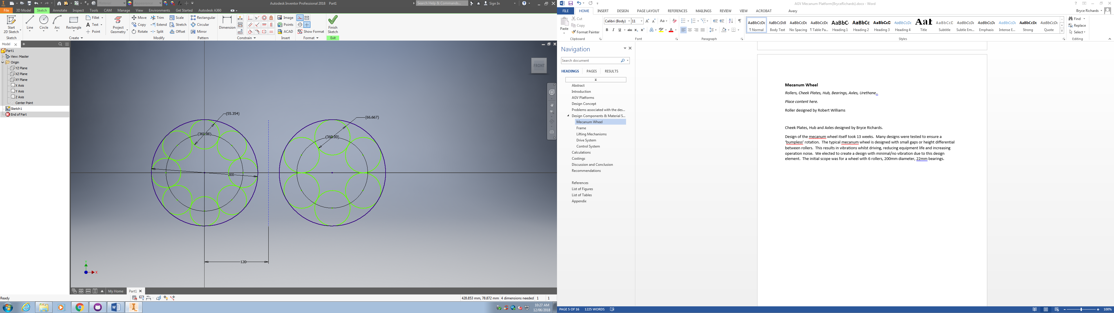

Following this I arrayed the 6 rollers at the design angle of 45° at a diameter which would effect a resultant 200mm as per the original scope.

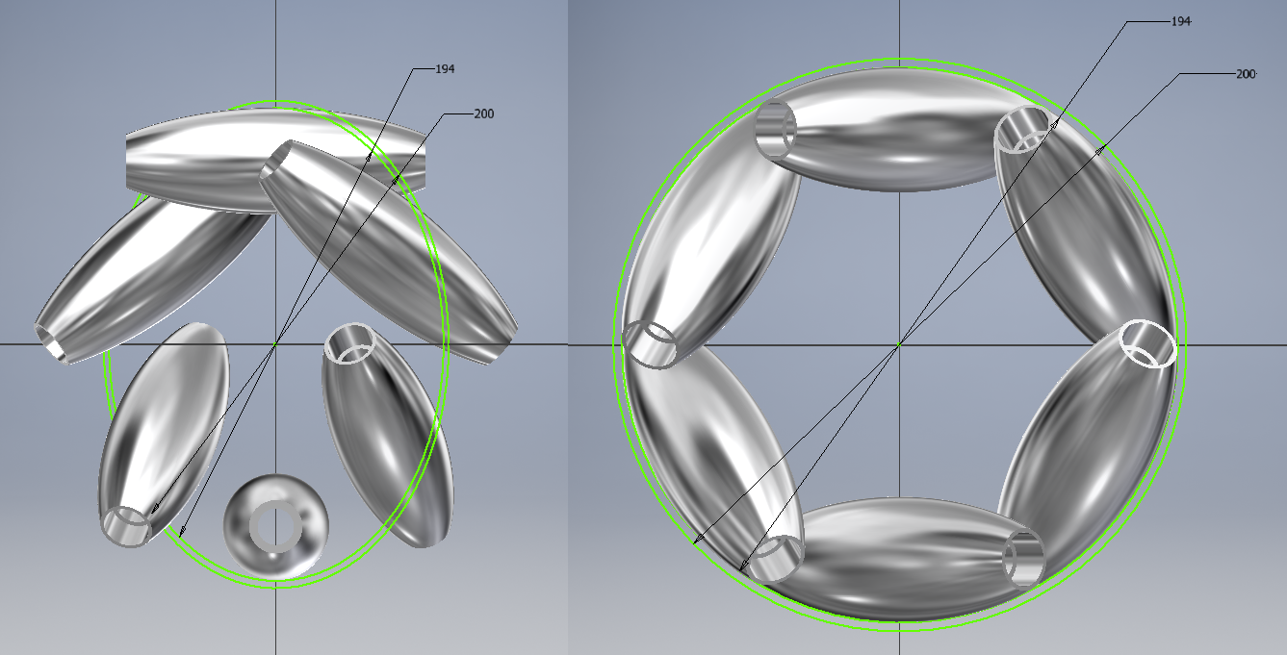

I then applied the Polyethylene cover to the rollers to get a final shape on the array.

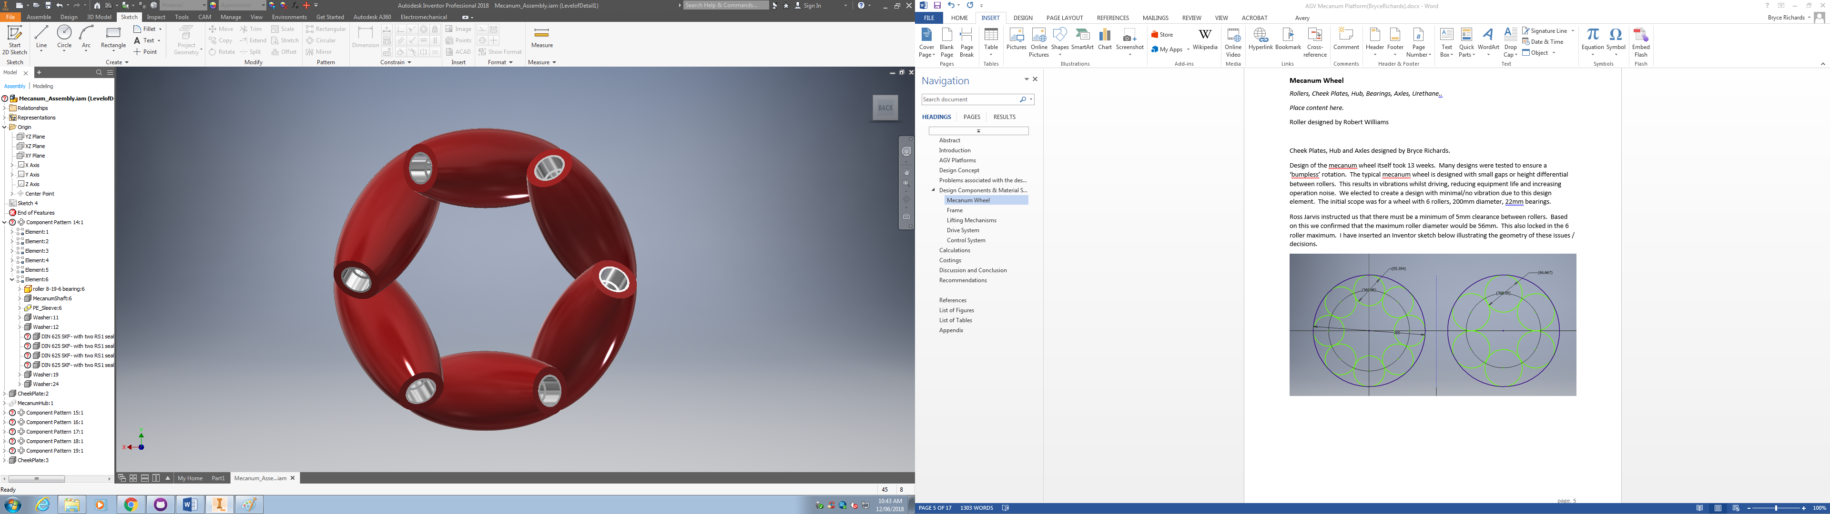

Next I checked with Adam Fiannaca (lecturer) and the thickest available aluminium plate would be 20mm. I superimposed a 20x200mm rectangle over the design to basically sight whether this was feasible for use in the cheekplate design. It was (not that the centreline of all shafts is basically contained within the green rectangles) so I proceeded to design the cheek plates.

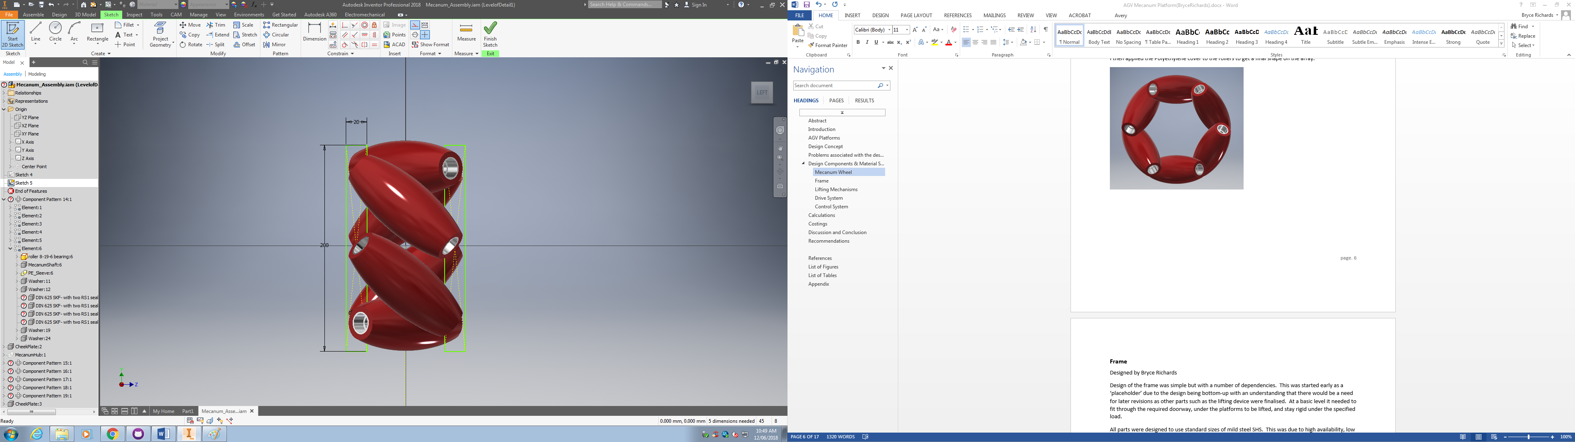

I then saved the above assembly and started a new *derived* part. The idea was similar to how I set up the rectangles in the above diagram. Now that we knew where the rollers would sit, build a circular plate in-context then cut out the shape of the rollers from that plate. This would ensure that everything remained aligned (as the geometry of the design was quite complex). As per the below I created an offset plane 50mm out from the XY plane (no real science, looked about right by eye, easy to move later provided I keep the design in-context). I then drew the 194mm circle on this plane (diameter of the rollers without polyethylene covers) and extruded to a total width of 20mm, centre-out. This created overlap between the rollers and the new plate which could be cut out of the plate later.

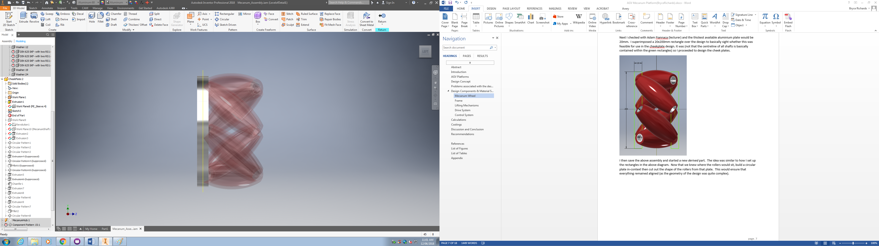

This next part was more complicated as I needed a plane down the middle of an angled roller offset from the centre of the plane space. I created a custom work plane on the face of the roller. By picking a roller which coincided with the Y axis this let me then create a midplane between the custom plane and Y axis. This plane was aligned with the centre of the roller.

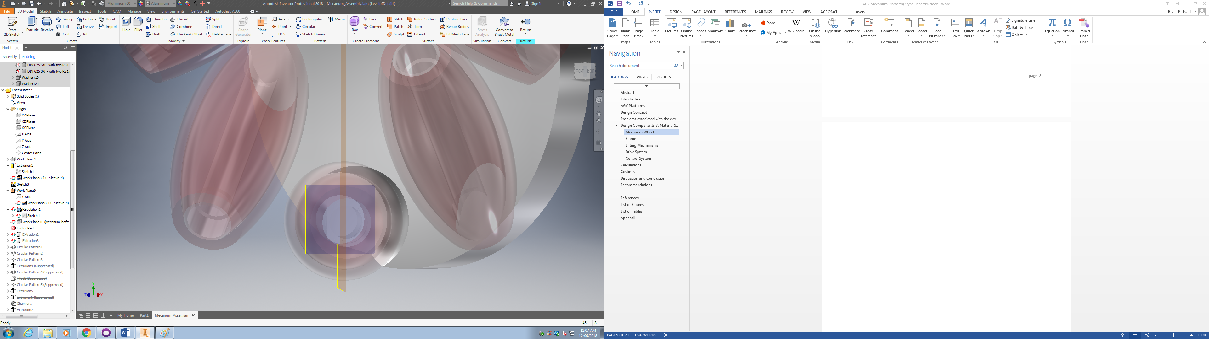

Next I drew the shape to cut out of the plate. This needed to be based on the geometry of the roller but with adequate clearance so that the roller could rotate inside of this cavity and not jam if small rocks or debris were to be caught. We held discussions with Adam Fiannaca and Ross Jarvis relating to this element of the design and we decided that 5mm of clearance along the curved surface and 1mm clearance on the face would be sufficient. I projected the polyethylene cover, offset that curve, and then made the requisite changes to create a fully contained polygon.

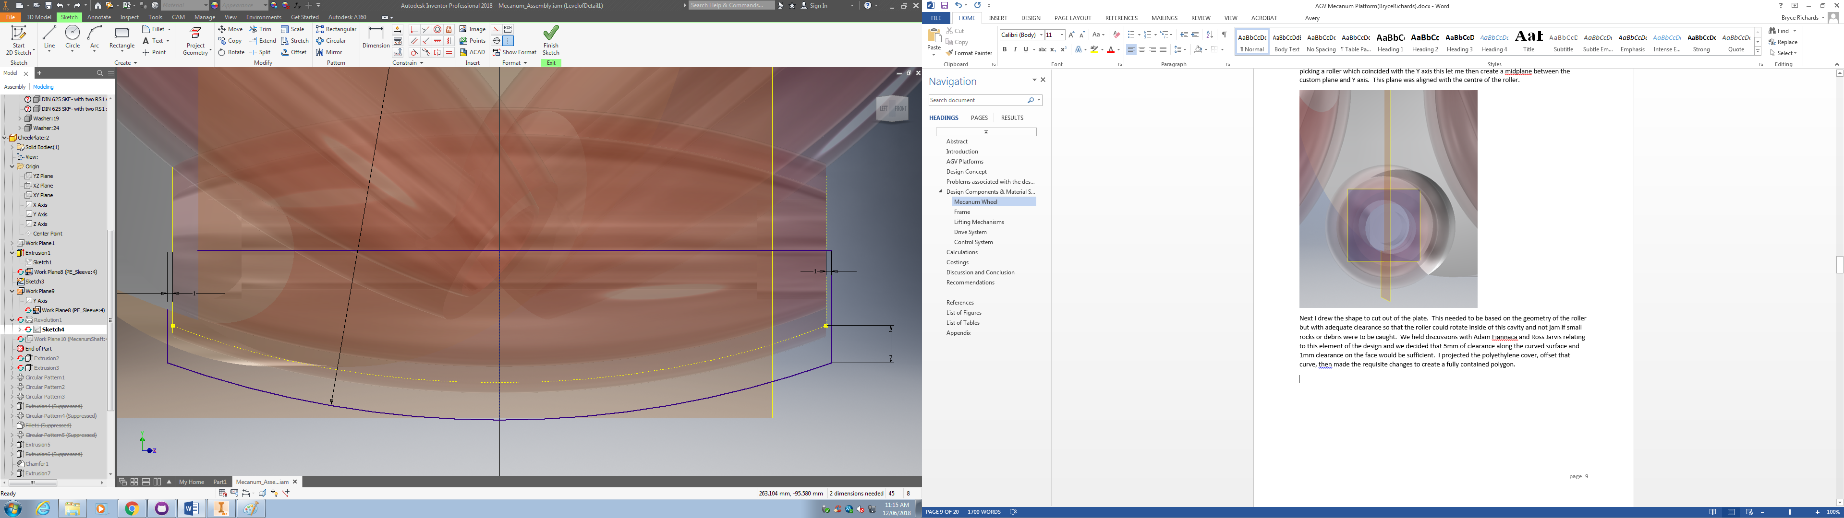

I then used the revolution tool to cut this shape out of the plate.

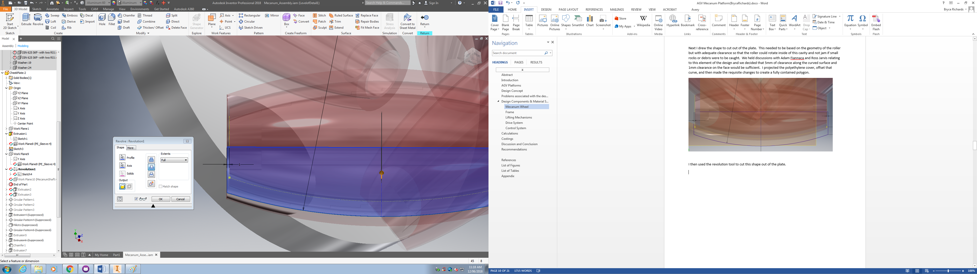

Next I offset the earlier custom plan out an arbitrary distance, drew a shape aligned to the roller axle, then extrude-cut back in to create a surface on which we could place a nut to secure the roller shaft.

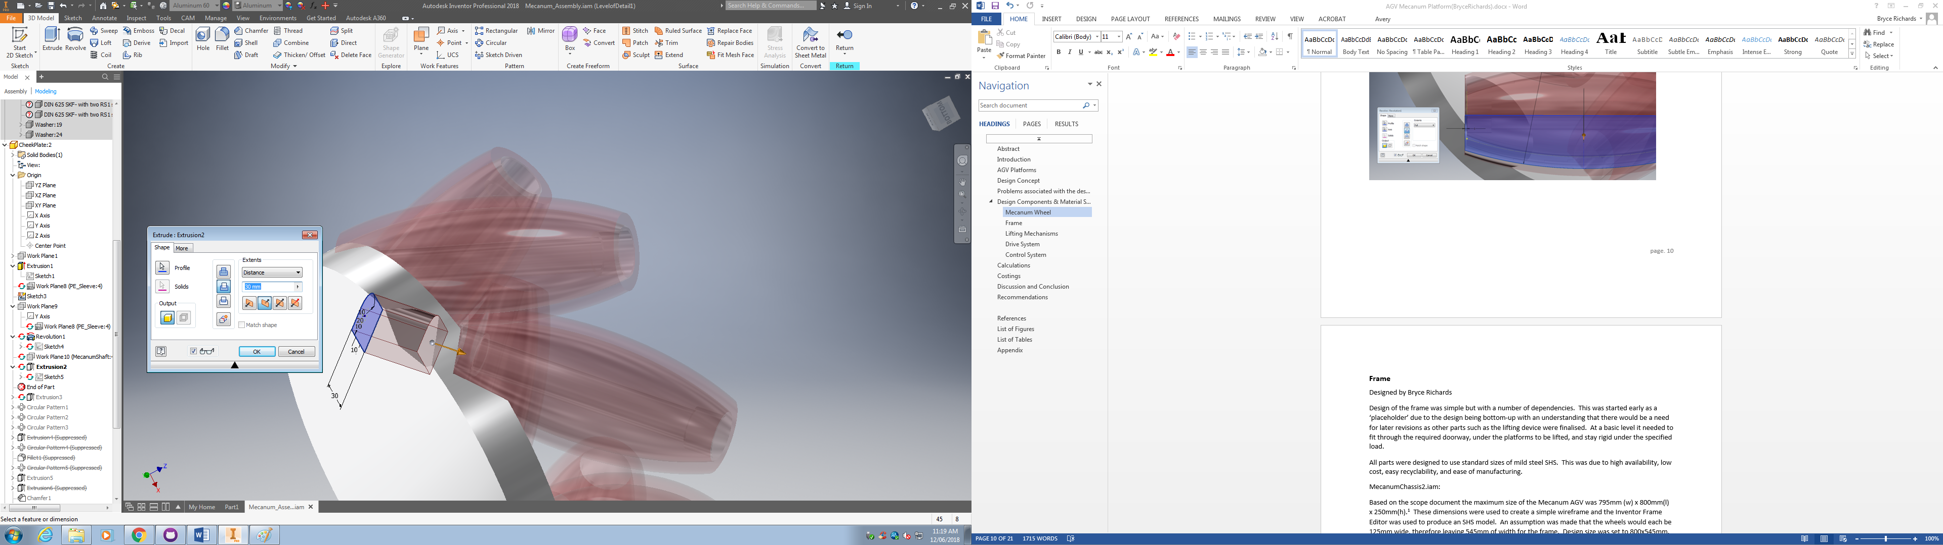

I now used the circular pattern tool to create 6 of both cuts aligned to the face of each roller. The circle was the 194mm original plate extrusion.

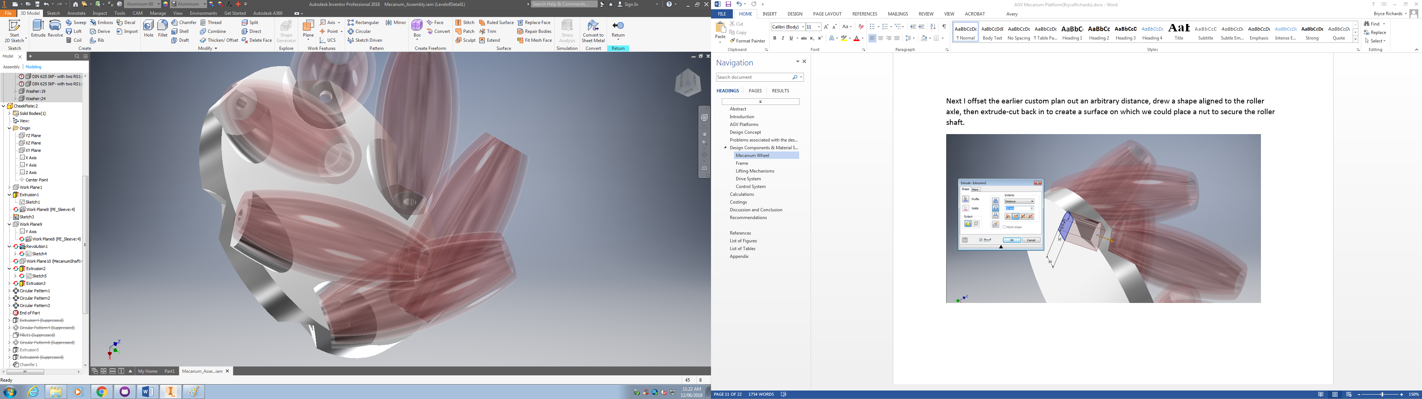

Finally I added mounting holes for the hub, a keyhole for the main axle, chamfers and radius as required. This concluded the design of the check plate. I also produced 2D drawings for quotation purposes.

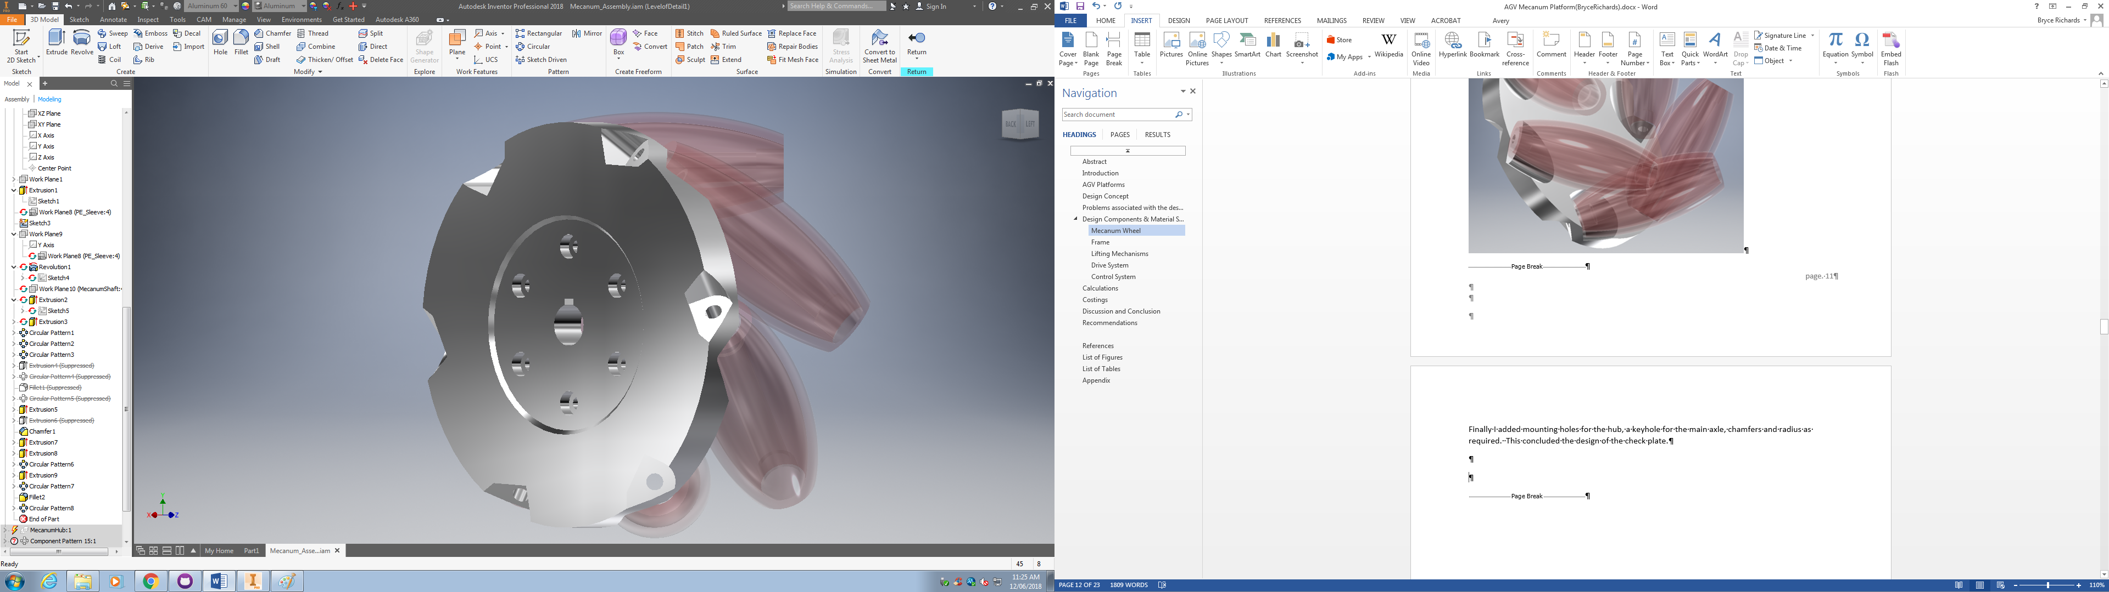

**Hub designed and written by Cyprian Sino.**

Hub design had to be done to suit the cheek plate and decision was to be made whether to produce a hub as a single unit or as parts. After choosing the material as aluminium we decided as a group to have the hub in three parts comprising two end flanges and a pipe in the centre which would be welded to the flanges.

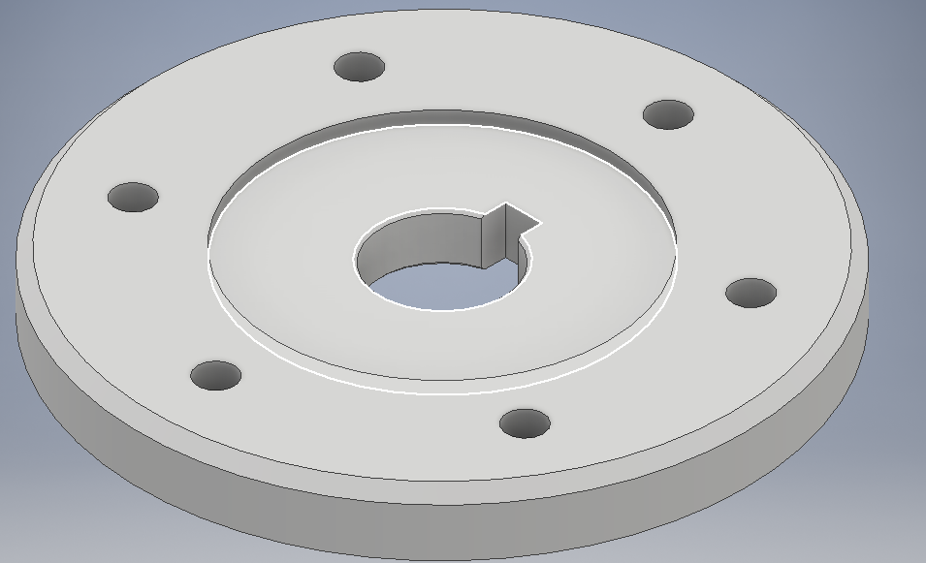

The small step or recess on the ipt is where the pipe will be mounted and welded on. An stp file was created form this to enable for 3D printing when we produced the prototype wheel.

Fig. B is the drawing which l made for the manufacturing of this part, we used this drawing to get a quote for machining. All parts which needed to be sourced from outside we made drawings like the one above and send them for machining prize so as to determine our budget. All of the drawings were done to AS 1100 standards.

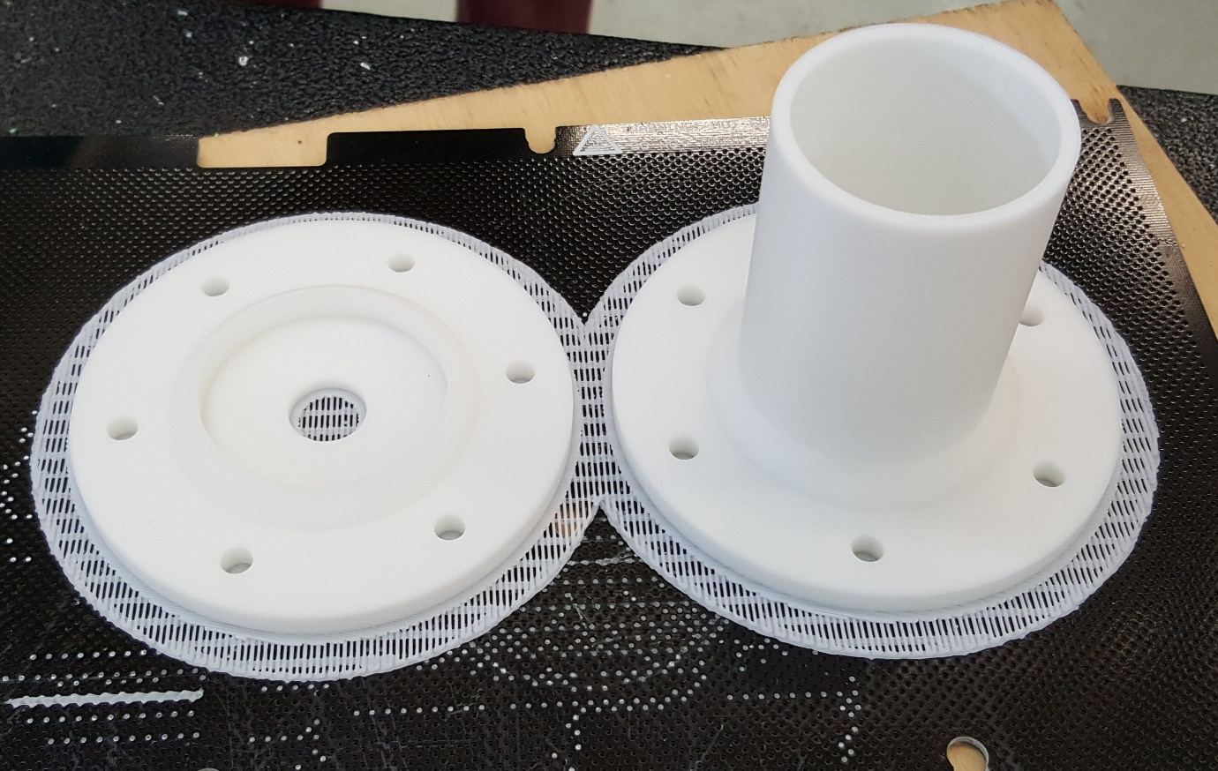

This is the hub after 3D printing and ready to clean and use on the model. The actual hub will have separate flanges which are going to be welded together onto an aluminium pipe of the same grade, in our case we are going to go for Al 6061.

Wheel Shaft

Written and designed by Bryce Richards.

WheelShaft.ipt

Design of the wheel shaft (that is, the primary axle) was essentially predicated on the size of other components.

Initial ideation was performed by myself and Adam. We discussed creatively what method should be used to secure the wheel to the axle, the axle to the frame, and the axle to the drive system. The following is a sketch from that session:

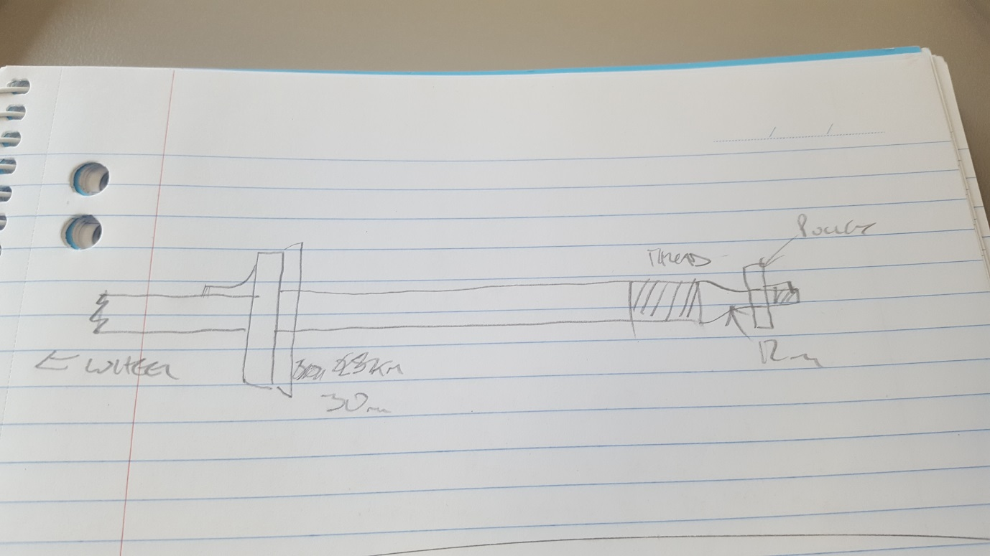

From here we sourced lengths for the wheel, hub and pulley and produced a technical drawing for fabrication. The shaft was designed with a standard 6mm x 6mm key for the wheel and 4mm x 4mm key for the pulley. As the cheekplate was made from 6061 aluminium we also checked the load mathematically to ensure that the plates would not compress / wear.

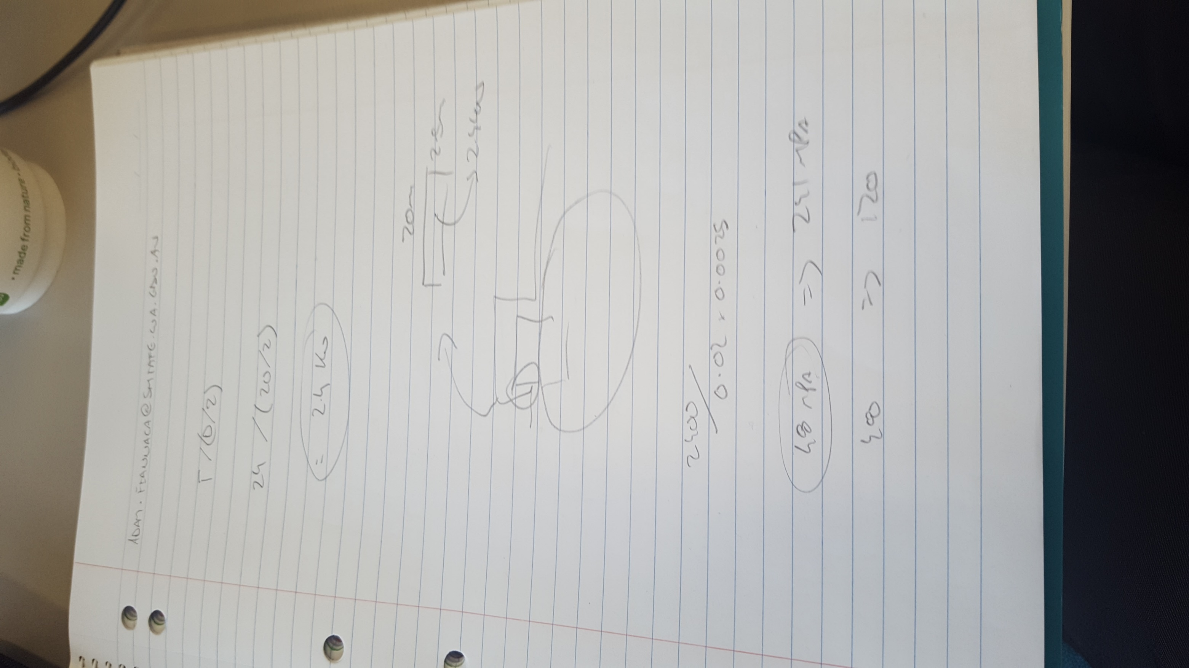

### Frame

Designed by Bryce Richards

Design of the frame was simple but with a number of dependencies. This was started early as a ‘placeholder’ due to the design being bottom-up with an understanding that there would be a need for later revisions as other parts such as the lifting device were finalised. At a basic level it needed to fit through the required doorway, under the platforms to be lifted, and stay rigid under the specified load.

All parts were designed to use standard sizes of mild steel SHS. This was due to high availability, low cost, easy recyclability, and ease of manufacturing.

MecanumChassis2.iam:

Based on the scope document the maximum size of the Mecanum AGV was 795mm (w) x 800mm (l) x 250mm (h).[8] These dimensions were used to create a simple wireframe and the Inventor Frame Editor was used to produce an SHS model. An assumption was made that the wheels would each be 125mm wide, therefore leaving 545mm of width for the frame. Design size was set to 800x545mm. Initially 45x45x1.6mm SHS was selected. An iterative process was used via which a size of SHS was selected, tested in the ‘Frame Analysis’ environment, then revised accordingly. The process repeated until a final selection was made of 35x35x1.6mm SHS which could tolerate the 500kg load with < 300MPa stress.

Two changes were necessary to the frame as the project progressed:

1. Once the design for the wheel hub was finalised it became apparent that the full 545mm was not available. The width of the frame was therefore reduced to 515mm to allow space for outboard nuts on the axle.
2. Late in the project Ross revised the scope up from a 500kg maximum payload to 1000kg maximum payload. Due to this it was necessary to increase the SHS thickness to 3mm.

LiftPlate.iam:

The lift plate followed the basic design of the chassis described above including late-stage reductions in width and increases in thickness. Design of this part was ultimately dependent on the lifting mechanism. The size of the gearbox for the lifting device determined the final size of the lifting plate – this caused the team to move the position of the legs of the lift plate to align with this device.

Following the above a group of 2D drawings were produced for fabrication. These were of the top and bottom of the chassis, and then the lifting plate (see figures A, B and C). These 2D drawings were used to cut and weld the selected 35x5x3mm SHS as required.

Cutting SHS to length:

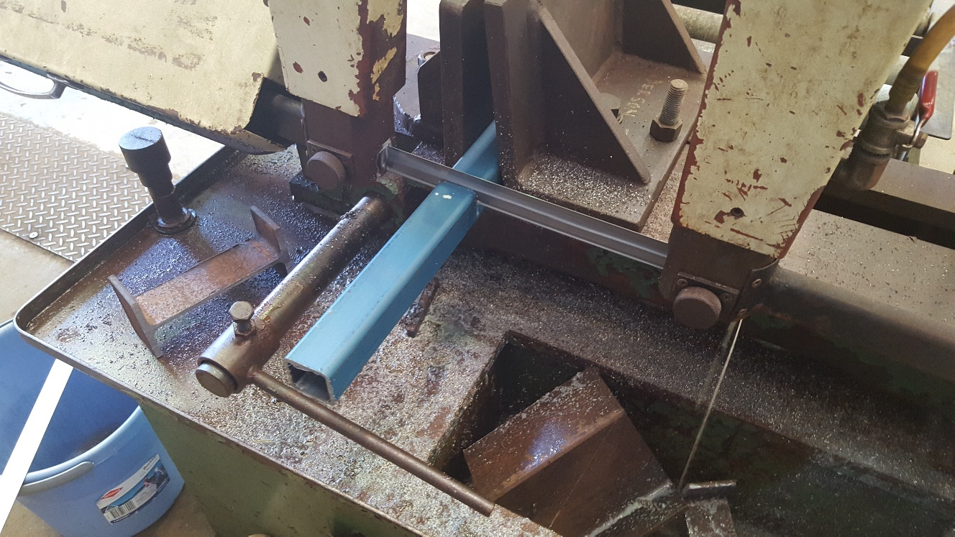

Cutting SHS 45° angles:

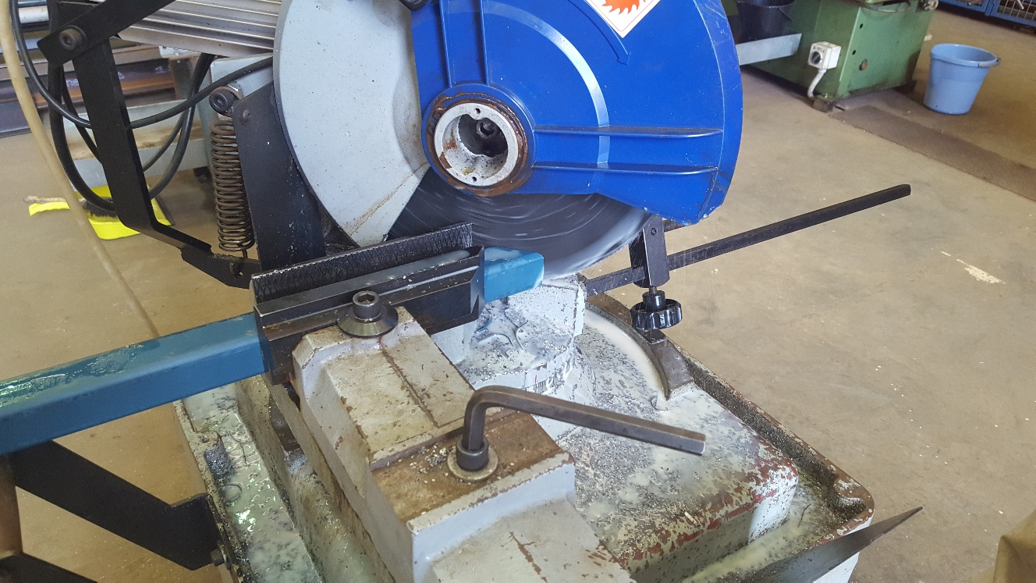

Preparation for welding SHS:

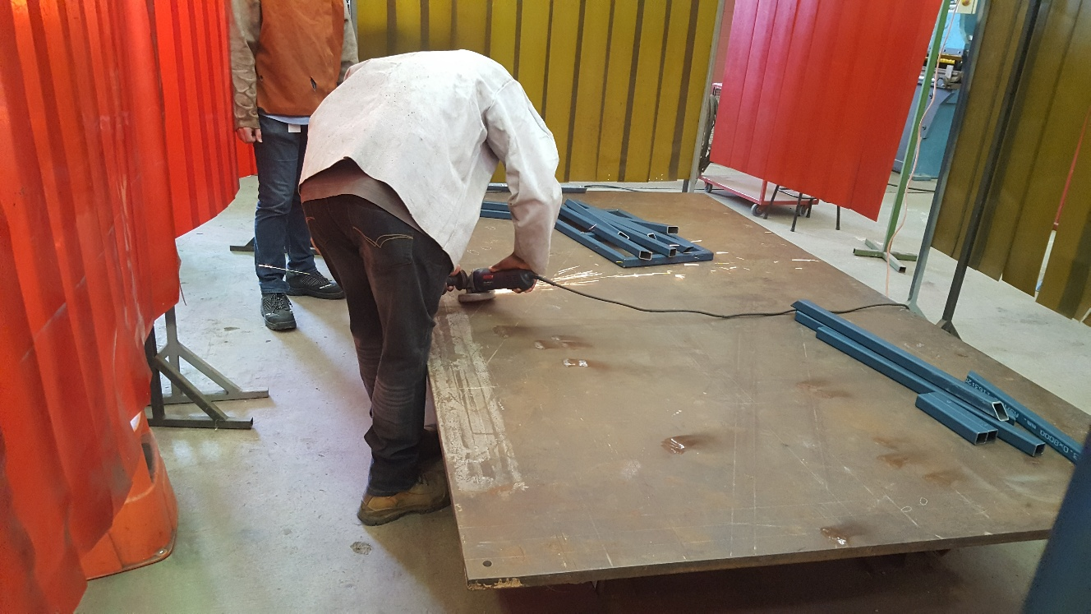

Top frame welded:

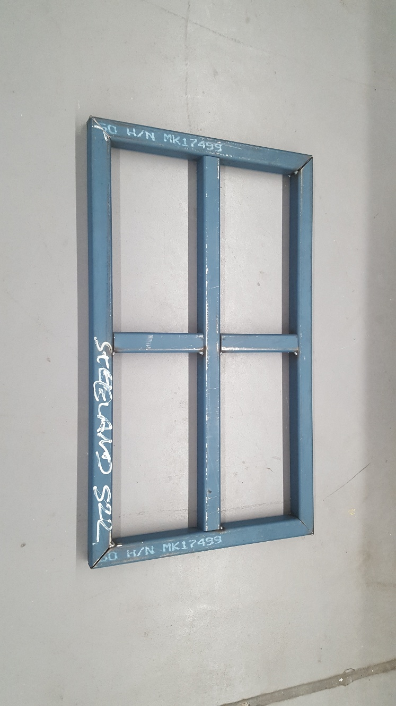

Base frame welded:

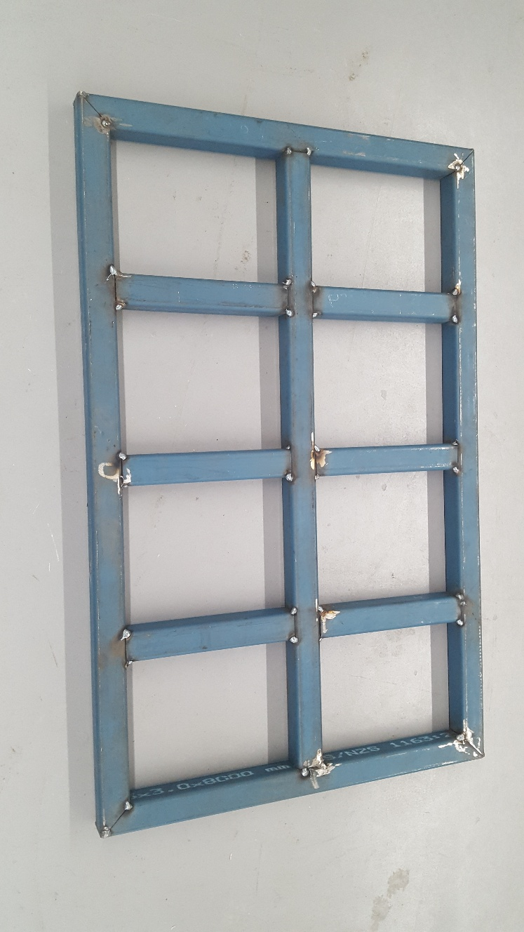

### Lifting Mechanisms

*Electro-mechanical: Gearbox, motor, ball screw, bearings, linear rail, etc.*

*Place content here.*

Designed by Bryce Richards.

The design of an electro-mechanical lifting system was iterative, due to issues such as parts availability and prohibitive costs. Initial part selection was of a screw jack. These are pre-fabricated worm-gears with integrated ball screws and lifting devices. They are used commonly in industry for high-precision positioning of heavy loads. Unfortunately these proved to be prohibitively expensive in the sizes we were looking for as they are simply not a common component (use case is very small). Price of the E-Series Power Jacks[9] model was quoted at $2154.89 each[10], or $8619.56 for the set of 4 required for the design. Due to this we elected to not use an off-the-shelf component and design a device ourselves.

We had a group discussion (Bryce Richards, Robert Williams and Adam Fiannaca) regarding design of a custom lifting device. It was decided that we would use a worm gear (i.e. 90° gearbox) mated to a ball-screw. We had a maximum design height of 160mm and needed an effective lift height minimum 75mm.

Initially we looked at an inline coupling to a gear shaft. We selected a Ruland MCLX12-12-F[11] for this purpose, but ultimately the coupled design proved larger than 160mm so we moved to a through-shaft design.

We looked at a variety of worm gears such as the Ketterer Worm Gear[12], and the PBX-081[13], before ultimately deciding on the TIDEFEEL TS-58GZ868D[14]. This selection was due to the very low purchase price ($54USD) and simple design. Our intent was to remove the OEM output shaft and replace it directly with a machined ball screw.

**Lifting Mechanisms**

**Gearbox**

Written by Purnima Samararatne (M227958)

To design the gearbox in inventor which later would be placed on the frames, we were looking for a high torque shaft gear box motor the one Bryce told me look for was a TS-58GZ868D this is a good motor as it can change the shaft rotation direction.

Also this gearbox has some good characteristics as the gearbox itself is in the shape of a rectangle it can easily be placed on our frames and with self- locking, the output shaft can’t rotate when the switch is off that is the self-locking. The website I was looking at gave me dimensions of the gearbox which I had to make 3-D version in inventor.

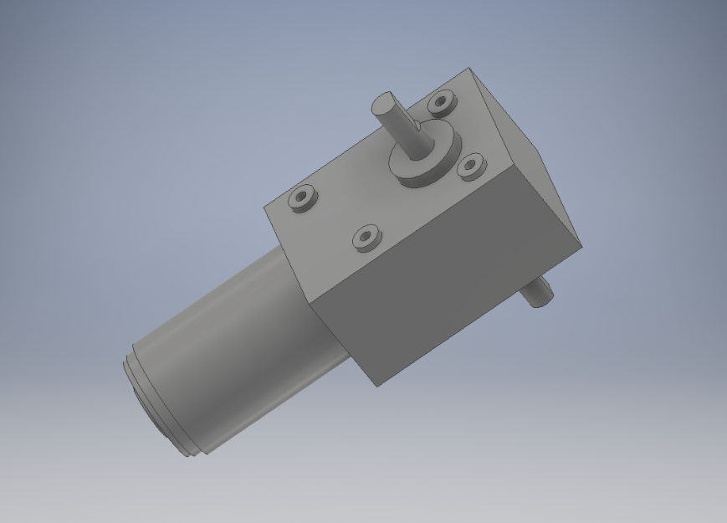

I applied some material to the drawing

### Drive System

Synchronous Pulleys and belts

Designed and written by Cyprian Sino.

The design required for us to look into getting a small compact set of pulleys and belt with enough grit to move the AGV vehicle carrying 500kg upwards, so using the initial calculation on the excel chart on GitHub l set out to draw and produce an assembly which would fit on the already finished frame without moving the motor or wheels. The (f, x) parameter table below is the one l used to design synchronous pulleys. The user parameters helped draw a different size by just inputting numbers in the equation. The user parameters helped me come up with the correct assembly to fit into the fixed gearbox, motor and wheel assembly. This chart also helped me on my tooth design and moulding, l also got material from an attachment l uploaded on GitHub-mecanum doc (Catalogue for pulley and belt selection).

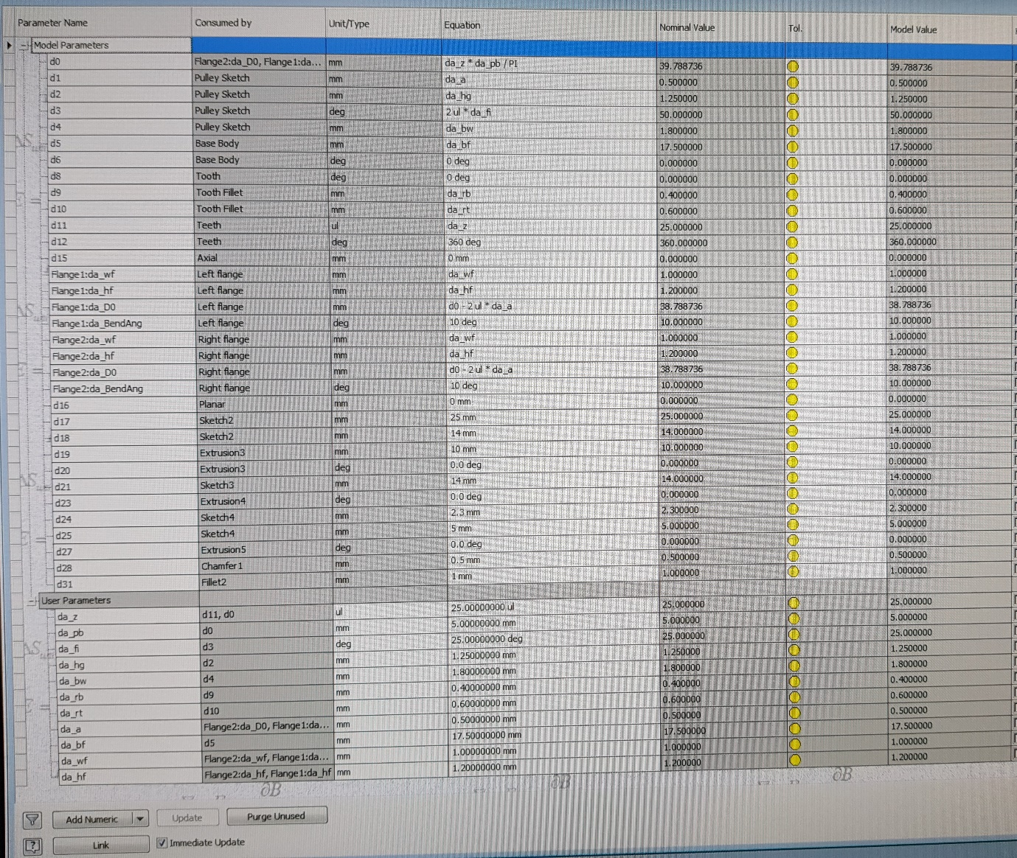

FIGURE H is just a simple drawing of the pulley l made as l did not need to do a manufacturing drawing. The synchronous pulleys are pre-manufactured and you only need to specify the size from the catalogue the bore and keyway size to order.

Pulley Information

** **Type --------------------------------- 27T5/ 25-2 (-2 means type 2 which is Aluminum)

** **Number of teeth----------------- 25

** **Bore size---------------------------- 14mm for the motor side.

---------------------------- 12mm for the wheel side.

* **1 x pulley for the motor.**
* **1x pulley for the wheel side.**
* **Pulley to be made of Al 6061.**
* **Motor side pulley to have a 5mm standard keyway cut.**
* **Wheel side pulley to have a 4mm standard keyway cut.**

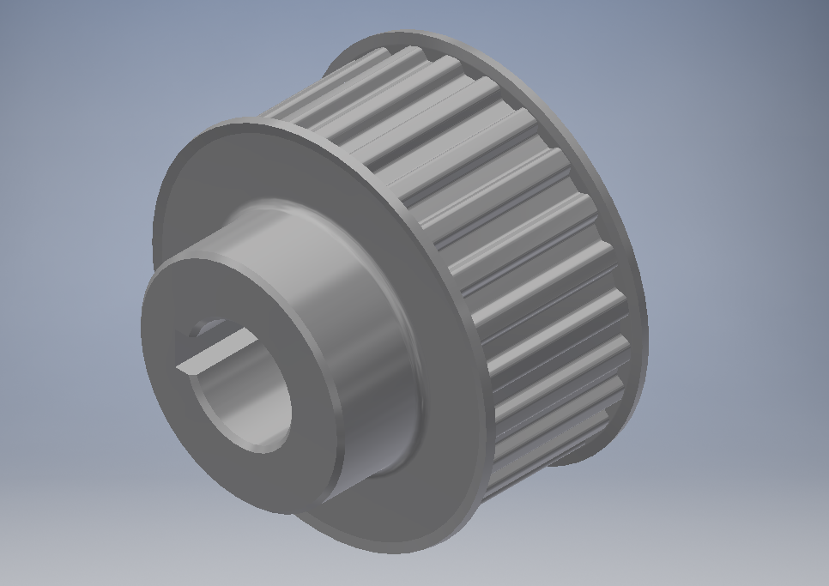

This is the ipt part of the pulley that l designed and the only difference between the two pulleys is the bore size and keyway size, one has a 12mm bore with a 4mm keyway and the other has a 14mm bore and a 5mm keyway

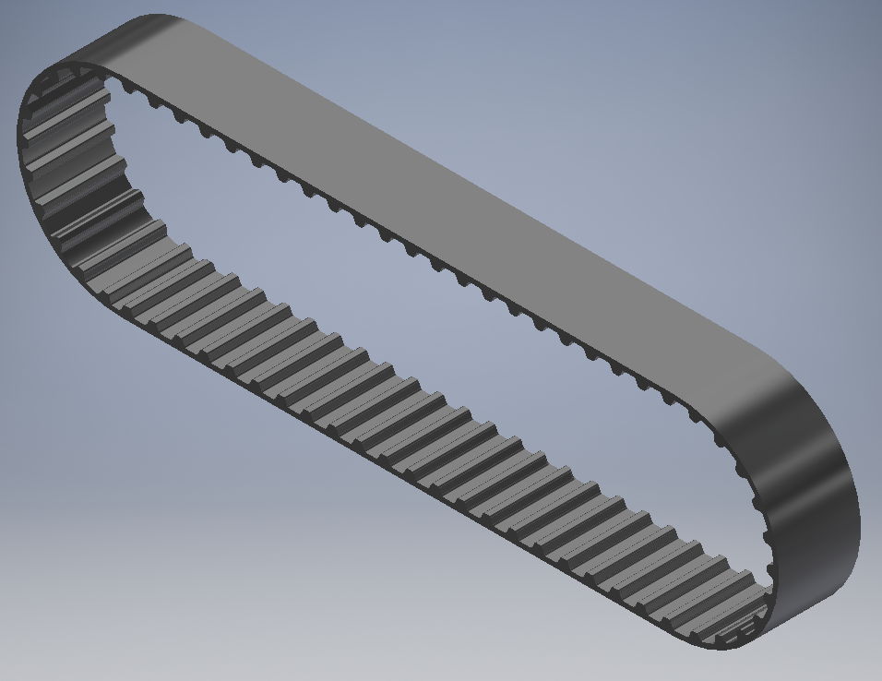

This the ipt for the belt which l designed. This belt can also be ordered from supplier without giving them a dwg drawing. All l needed to do is look up in the supplier catalogue for the belt which l had finally designed that is the number of teeth and the width and get a part number. I then used the part number to get a quote, which was easier on my part because l did not need to produce a drawing.

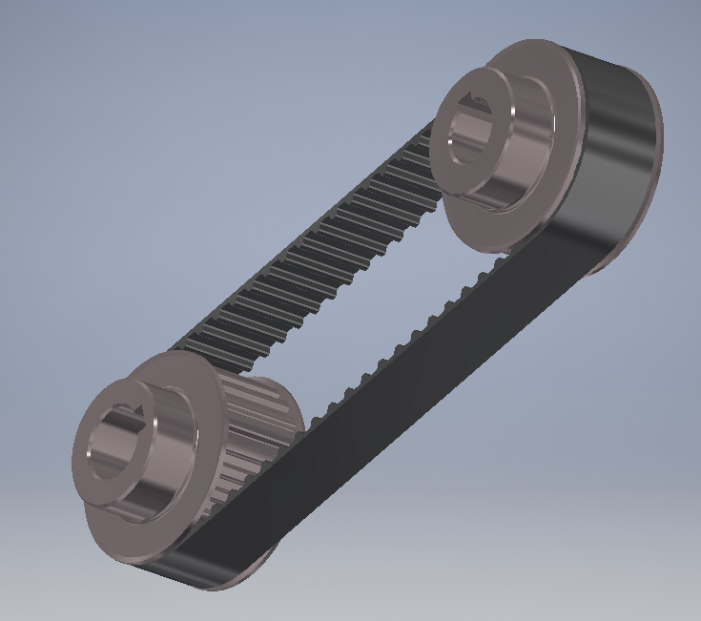

This is the full assembly of the pulleys and belt ready to pop onto the main assembly of the AGV. This assembly fits straight on as the centre distance on it is exactly as is on the assembly. I have changed the appearance of the pulleys just to make it look good but is actually made of 6061 Aluminium which is machinable.

I did some stress analysis of the belt and pulley assembly and these are some of the results, the full report is on GitHub (Mecanum doc)

On the

|  |  |  |  |
| --- | --- | --- | --- |
| Name | Aluminium 6061-AHC | |  |
| General | Mass Density | 2.7 g/cm^3 |  |
| Yield Strength | 275 MPa |  |
| Ultimate Tensile Strength | 310 MPa |  |
| Stress | Young's Modulus | 68.9 GPa |  |
| Poisson's Ratio | 0.33 ul |  |
| Shear Modulus | 25.9023 GPa |  |
| Part Name(s) | Sync pulley.ipt | |  |
| Name | Polyethylene, High Density | | |
| General | Mass Density | 0.952 g/cm^3 | |
| Yield Strength | 20.67 MPa | |
| Ultimate Tensile Strength | 13.78 MPa | |
| Stress | Young's Modulus | 0.911 GPa | |
| Poisson's Ratio | 0.392 ul | |
| Shear Modulus | 0.327227 GPa | |
| Part Name(s) | Synchronous Belt | | |
| Name | Steel | |  |
| General | Mass Density | 7.85 g/cm^3 |  |
| Yield Strength | 207 MPa |  |
| Ultimate Tensile Strength | 345 MPa |  |
| Stress | Young's Modulus | 210 GPa |  |
| Poisson's Ratio | 0.3 ul |  |
| Shear Modulus | 80.7692 GPa |  |
| Part Name(s) | Synchronous Pulley1 Synchronous Pulley2 | |  |







F2 1.03 Hz X Displacement

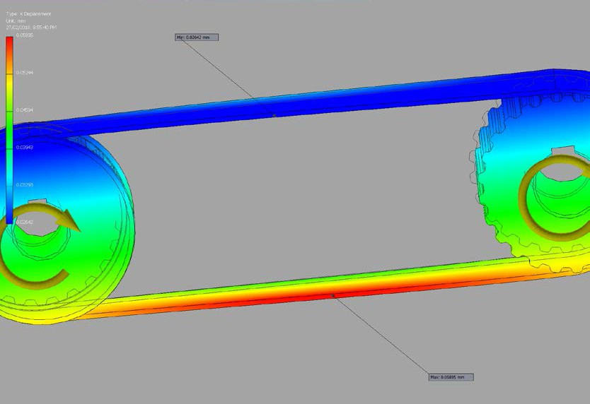



F2 1.03 Hz Y Displacement

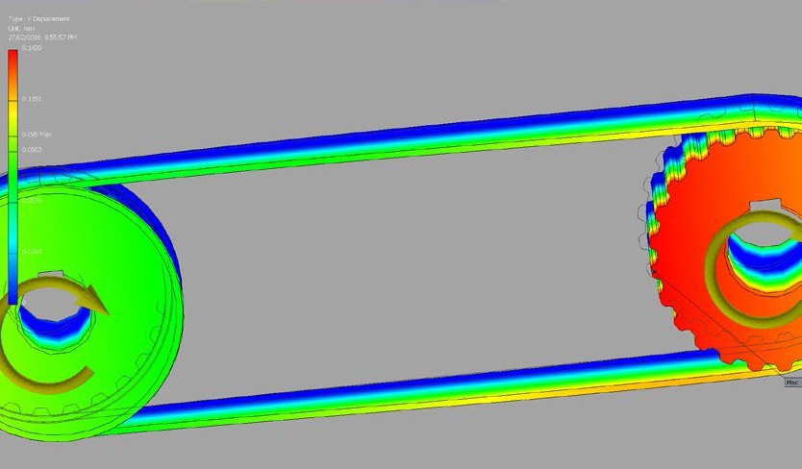



F4 1.05 Hz Displacement

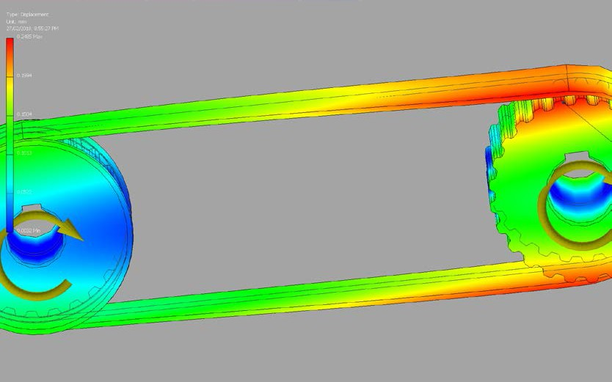

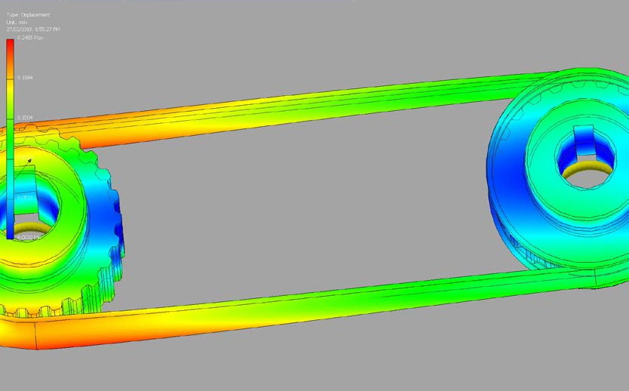

For the full report and more please refer to the GitHub mecanum doc ‘Modal analysis of synchronous pulleys and belt’ by Cyprian Sino.

I also got a quote for the boring of the pulleys to required size, the cutting of keyways and the belt is in FIGURE T.

**Motor**

Written by Zixiao Tang (m234547)

Mecanum wheel mobile lift platform, based on mecanum wheel system. This kinds of mobile platform can move forward, sideways and oblique movement. Even zero radius turn movement.

The requirements needed to find the correct motor for the mecanum wheels was done by use of calculating the required torque and thereafter finding a motor which could handle said torque.

The calculations found that in order for the device to move at about 2 Km/h (max), the required torque when crabbing was 13,77 NM and needed an angular velocity of about 52 rad/s. Thereafter it was advised to find a stepper motor for said torque and angular velocity.

The stepper motor which was found was a Bipolar Stepper Motor. This motor was found on stepper online from the following link: https://oceancontrols.com.au/MOT-126.html

In our group design the gearbox needed to connect mecanum wheel and step motor as well. The gear box which was we chosen was ENCONOMIC INLINE PLANETARY GEARBOXES PTN060. This gearbox was found online from the following link[15]

The steel bracket lets us securely mount typical NEMA 23-size stepper motors and gearbox to our project. The bracket features two slots for various mounting solutions and includes four M4 x16mm screws, washers, and nuts for securing the motor to the bracket. The steel bracket we can’t find the exactly one online to matching our gearbox, So we design it, 65mm long, 60mm wide and 65mm high, 5mm thickness , the picture are showing below.

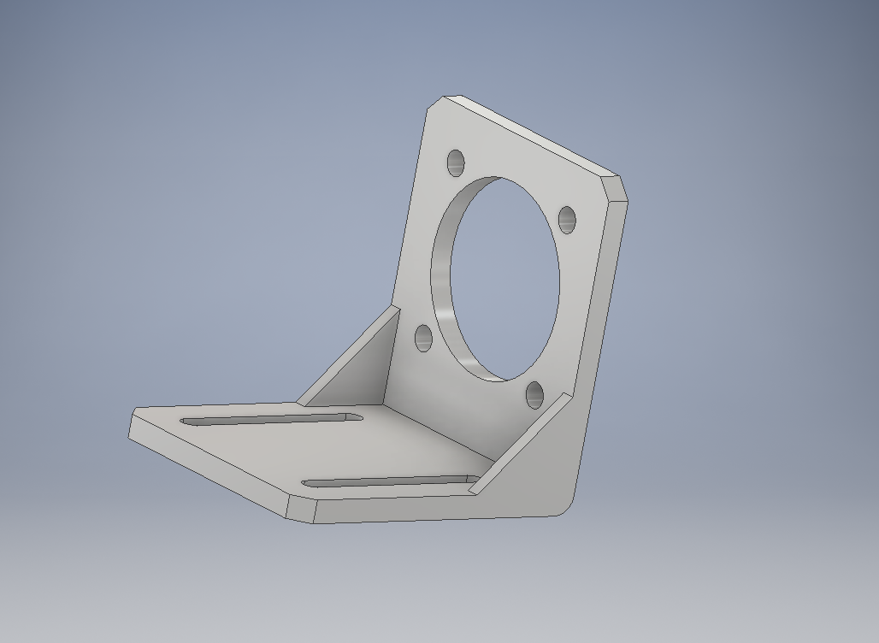

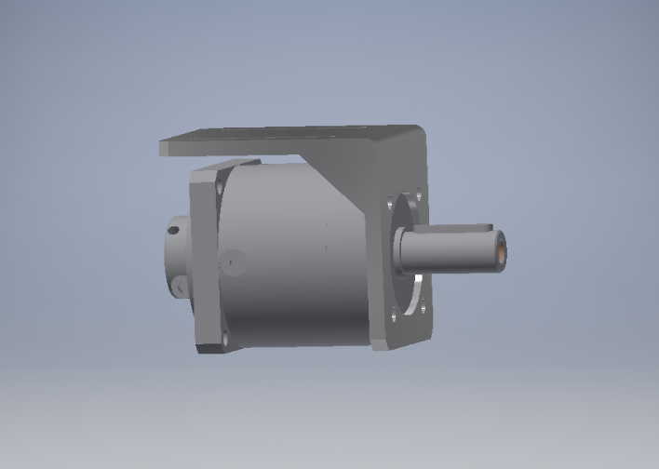

The bracket will be built in workshop. [16]

### Control System

Written by Gurkaran Singh (M234676)

Out of different navigation systems, group agreed on navigation with Magnetic Tape Guidance with Dead-Reckoning. It is a reliable and budget friendly system. The whole idea is to lay down a magnetic tape on the floor on the path where the AGV is supposed to go and it will use Dead-Reckoning to know how far away it is from the destination or when to turn. Magnetic tape was chosen over the optical guidance. Optical Guidance was dropped because of the maintenance, as the paint could get scratched off easily and even the dust can cause sensor to not sense the path. Magnetic Tape Guidance is an easy to lay and low maintenance system. It is easy to change the path if needed to. Further, the tape laid on the floor can be epoxy coated for protection.

**Sensors**

* **Magnetic Track Sensor**

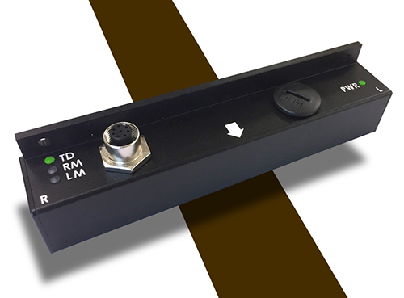

This sensor is capable of detecting and reporting the position of a magnetic field along its horizontal axis with an operating height of 10mm-60mm. The sensor accurately measures its lateral distance from the centre of the track, with millimetre resolution. The sensor can detect and manage 2-way forks and can be instructed to follow the left or the right track using commands issued via the serial/USB.[17]

* **Magnetic Tape Roll**

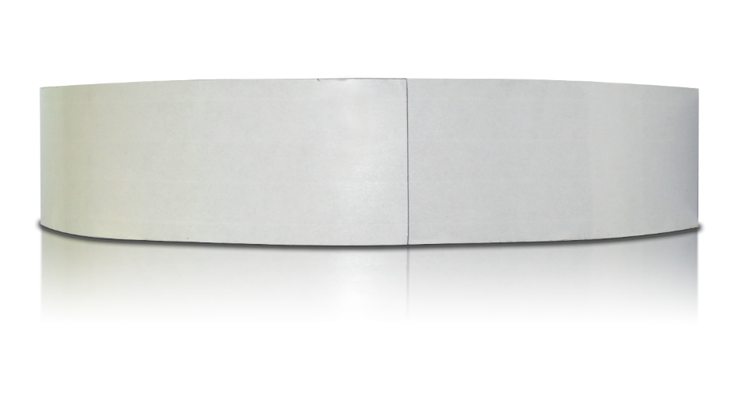

The magnetic tape roll is 45.7 m long by 0.0508 m wide with south side up. The tape can simply laid on the floor forming a path for the platform.[18]

* **Motor Controllers**

The motor controller divides a full rotation into a number of equal steps. The motor’s position can then be commanded to move and hold at one of these steps without any position sensors or the feedback, which allows every motor to perform independently. This will allow each mecanum wheel to operate independently, allowing the platform to go straight or crab.[19]

* **Collision Avoidance**

AGV operating in a work environment with people moving around it, should be able to detect any obstacles in its path, to avoid any collisions. One of the common collision avoidance method is to use optical sensors, which uses an infrared transmitter/receiver. Transmitter emits a pulse to illuminate the surrounding environment, then sensors on the vehicle detect changes to the surrounding environment between successive and the information is fed to the control unit. Control unit uses the information to calculate the distance to nearby objects. If the distance falls within a certain range the system will take action.

* **Encoders**

An encoder is a device which converts information from one format to another. In this case the encoders will be used to translate rotary motion of the wheels to digital signal, which can be used in monitoring or controlling motion parameters such as speed, rate, direction, distance or position.[20]

## Calculations

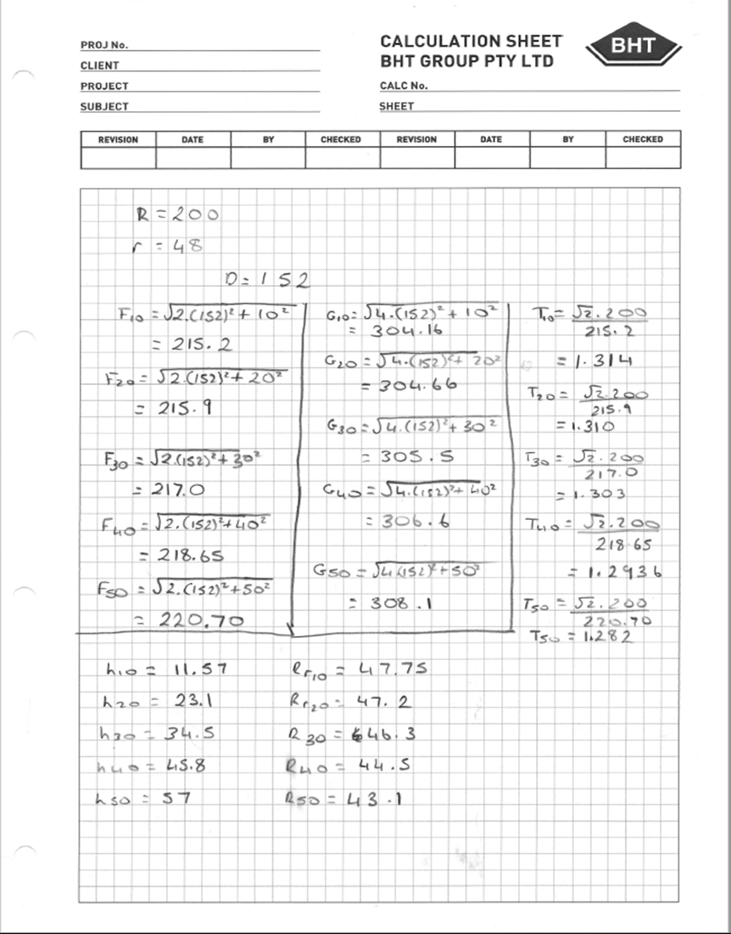

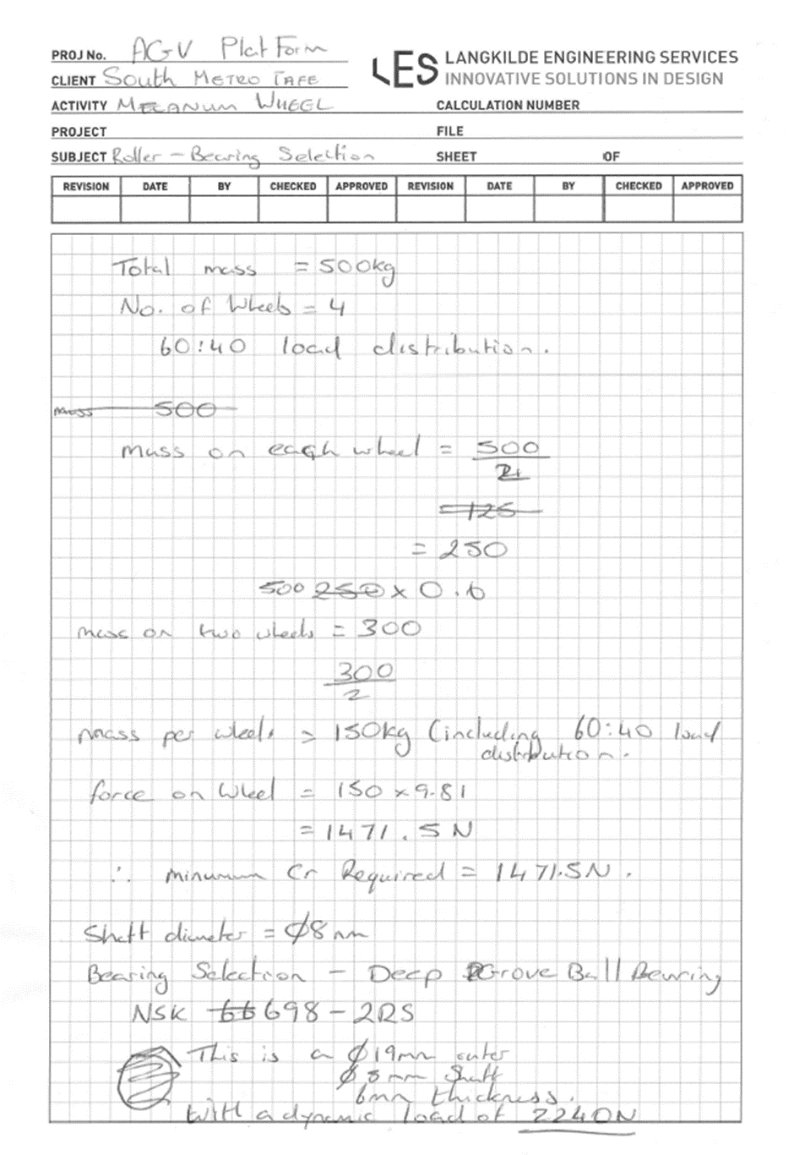

Some calculations used in calculating the number of teeth in pulley and belt

Number Teeth in Mesh (TIM) = Z1 [0.5 - (Z2 - Z1)p]

18.85A

Z1 =Number of teeth on small pulley

Z2 =Number of teeth on bigger pulley in my case the pulleys are the same and have the same number of teeth.

P = pitch

A = Actual centre distance

Z1 and Z2 = 25

P = 5mm

A = 107.50mm

Therefore 25[0.5-($\frac{(25-25)5}{18.85x107.5}$]

=12.5

Effectively that’s **13 teeth in mesh**

For drives with pulleys of equal numbers of teeth.

Calculate Number Teeth in Belt Nc = 2. $Ao$/p + Z1

Nc = number of teeth in belt

Ao = Approximate centre distance in mm

P = belt pitch in mm

Z1 = Number of teeth in small pulley

Therefore 2x $\frac{108}{5}$ + 25

= 68.2

Number of teeth in belt is equal to **68**

It was also noted that the Nc was always to be greater than 0.9(Z1+Z2)

A =p/4 (NA - Z1 + Z2 + (NA - Z1 + Z2)2 -2.027 (Z2-Z1)2 )

2 2 10

A= Actual centre distance

NA= number of teeth on belt

Z1 and Z2 number of teeth on pulleys

P = pitch of belt in mm

Therefore A= $\frac{5}{4}x (68-\frac{25+25}{2}+\sqrt{\left(68-\frac{25+25}{2}\right)}-2.027\left(25-25\right)2/10$

=**107.50mm**

## Costings

Written by Robert Williams, Gurkaran Singh

The scope specified that the total cost of the project should be kept to a minimum, this played a role in the design of the vehicle. Throughout the project design concepts were presented to the project manager, quotes were obtained and if it was deemed to be too expensive other avenues were explored. For example the lifting mechanism changed from pneumatic to electro mechanical initially off the shelf screw jacks was the chosen option, the quote came back from the supplier at $1958.99 per unit with 4 required. This changed the design concept from off the shelf to a self-designed lifting mechanism to reduce the total cost.

Table 1.1 below shows the costings obtained from suppliers, the costings are not complete as there is no quotes for the electronics, screws and nuts and bolts. All obtained quotes from suppliers and email correspondence are shown in the FIGURE Q, R. All mild steel pricing was taken from best buy steel website[21]

|  |  |  |  |  |  |  |
| --- | --- | --- | --- | --- | --- | --- |
| **Component** | **Use/ Notes** | **Material** | **Cost per Unit including GST ($)** | **Amount Required** | **Total Cost ($)** | **Supplier** |
| **Mecanum Wheel** |  |  |  |  |  |  |
| Bearings | 698-ZZ JP (8-19-6) |  | $4.40 | 96 | $422.40 | State-wide Bearings |
| Roller | Supply and Machine | Aluminium 6061 | $38.50 | 24 | $924.00 | Bluechip CNC |
| Cheek Plate | Supply and Machine | Aluminium 6061 | $302.50 | 8 | $2,420.00 | Bluechip CNC |
| Hub Flange | Supply and Machine | Aluminium 6061 | $82.50 | 8 | $660.00 | Bluechip CNC |
| Polyurethane | Cast | Shore A 95 Duro | $38.50 | 24 | $924.00 | Polyurethane Processors |
| ᴓ8mm Round Bar | 12.5m, 6m Lengths sold | Mild Steel 300+ | $14.15 | 3 | $42.45 | Best Buy Steel |
| ᴓ30 Round bar | 1.6m, 6m Lengths sold | Mild Steel 300+ | $76.20 | 1 | $76.20 | Best Buy Steel |
| **Mecanum Wheel Total** |  |  |  |  | $5,469.05 |  |
|  |  |  |  |  |  |  |
| **Frame** |  |  |  |  |  |  |
| 12m of SHS | 35x35x3 (sold 8m lengths) | Mild Steel | $61.75 | 2 | $123.50 | Best Buy Steel |
| Bearing housing base | Supply and Machine | Aluminium 6061 | $100.00 | 4 | $400.00 | Bluechip CNC |
| Bearing housing jack plate | Supply and Machine | Aluminium 6061 | $120.00 | 4 | $480.00 | Bluechip CNC |
| Bearing housing plate | Supply and Machine | Aluminium 6061 | $90.00 | 4 | $360.00 | Bluechip CNC |
| bearing | 7204 B JP (20-47-14) |  | $22.00 | 8 | $176.00 | State-wide Bearings |
| Drive Pulley | Supply and Machine |  | $147.10 | 4 | $588.40 | NAISMITH |
| **Frame Total** |  |  |  |  | $2,127.90 |  |
|  |  |  |  |  |  |  |
| **Lifting Mechanism** |  |  |  |  |  |  |
| Gear Box | TS- 58GZ868 |  | $53.60 | 4 | $214.40 | Alibaba |
| Trust Bearing | NTB 1226 (12-26-7.5) |  | $5.54 | 4 | $22.16 | RS Components |
| Ball screw and Lead nut | 16mm Diameter |  | $22.80 | 4 | $91.20 | Alibaba |
| **Lifting Mechanism Total** |  |  |  |  | $327.76 |  |
| **Control System** |  |  |  |  | $0.00 |  |
| Magnetic Field Sensor |  |  | $485 | 1 | $485.00 | Roboteq |
| Magnetic Tape (10 m) |  |  | $46.40 | 2 | $92.80 | Aliexpress |
| Motor Controller |  |  | $1.68 | 4 | $6.72 | Aliexpress |
| Encoder |  |  | $12.18 | 4 | $48.72 | Aliexpress |
| **Control System Total** |  |  |  |  | $633.24 |  |

## 

## Discussion and Conclusion

Written by Bryce Richards, Gurkaran Singh

At the end of the defined project period we had not completed the design. The mechanical design is mostly finished but some small elements such as linear rails and IP65 enclosures have not yet been selected. Additionally the electronics like sensors, limit-switches and micro-controllers have not been selected. Also the program has not been written due to the lack of electronic components.

Mechanically the design will lift the required loads. It is much smaller than comparable commercial units, and also has a production cost of <$8k, whereas commercial units will cost up to $30k and not be small enough for the intended use-case.

The finished design to date: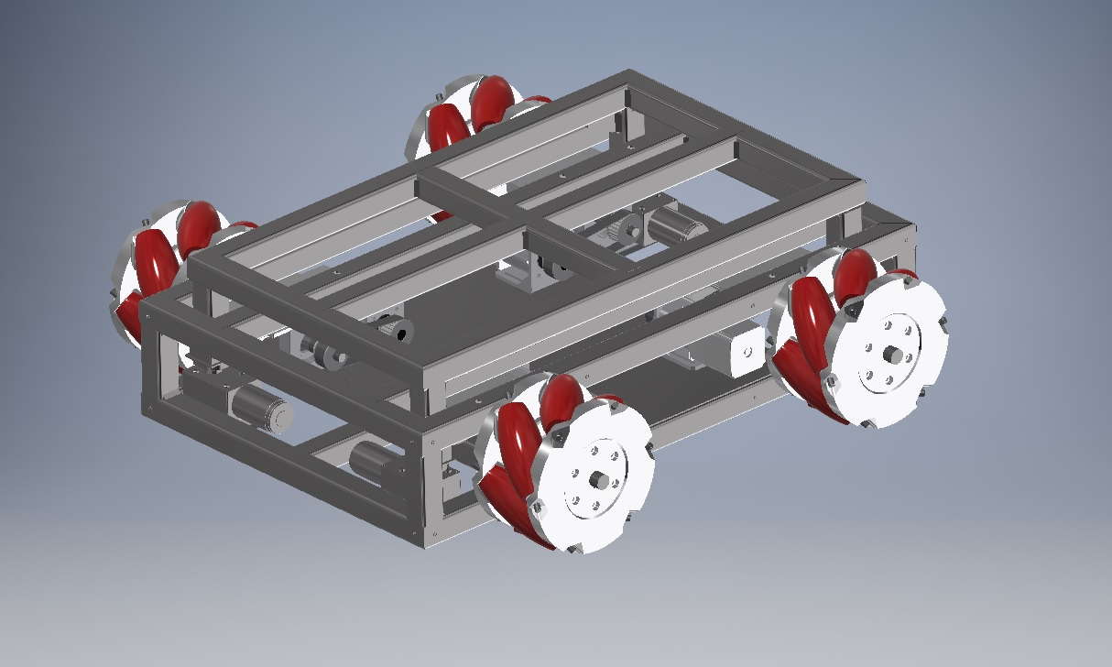

## Recommendations

Details on the state of the project are articulated above. The next step should be selection of suitable rectangular rail and working these in to the FinalAssembly.iam assembly. Space is available but may require design changes to the frame to accommodate.

## 

## References

APA referencing style

## List of Figures

|  |
| --- |
| FIGURE A: Airbag Recommendation |
| FIGURE B: CHEEKPLATE.dwg |
| FIGURE C: Hub Design |
| FIGURE D: Figure C: WHEEL_SHAFT.dwg |
| FIGURE E: Mecanum base1.dwg |
| FIGURE F: Mecanum base2.dwg |
| FIGURE G: Mecanum top.dwg |
| FIGURE H: Gearbox.dwg |
| FIGURE I: Pulley.dwg |
| FIGURE J: Motor Bracket.dwg |
| FIGURE K:Email correspondence |
| FIGURE L: SUPPLIER receiver.dwg |
| FIGURE M: AIR TANK |
| FIGURE N: GEOMETRY TO CALCULATE SHAPE OF ROLLER |
| FIGURE O: ROLLER GEOMETRY.dwg |
| FIGURE P: FINAL ROLLER.dwg |
| FIGURE Q,R,S: SUPPLIER QUOTES |
| FIGURE T: Quote for the boring of the pulleys |
| FIGURE U,V,W : BEARING HOUSING.dwg |

## 

## Appendix

FIGURE A





FIGURE B.

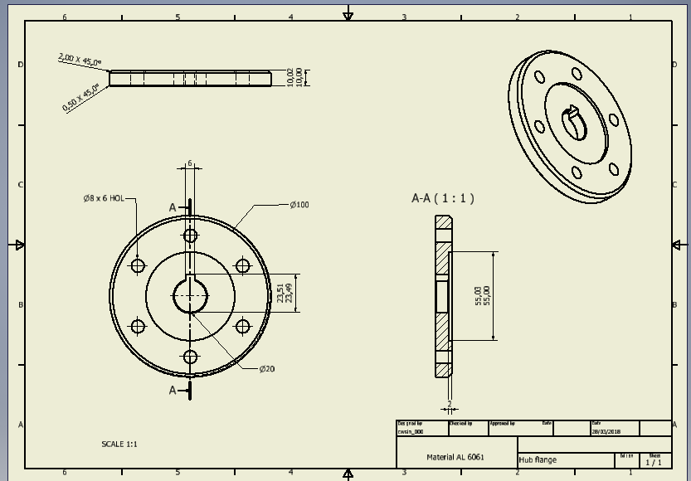

FIGURE C



FIGURE D



FIGURE E

FIGURE F

FIGURE G.



FIGURE H.

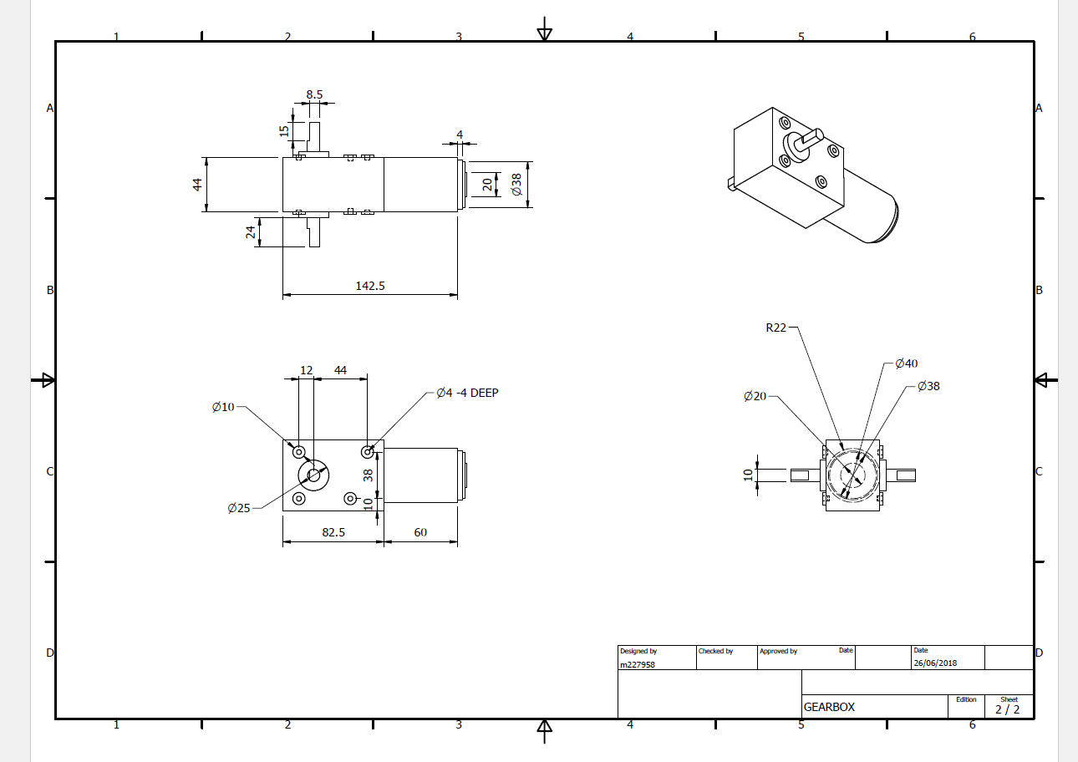

FIGURE I

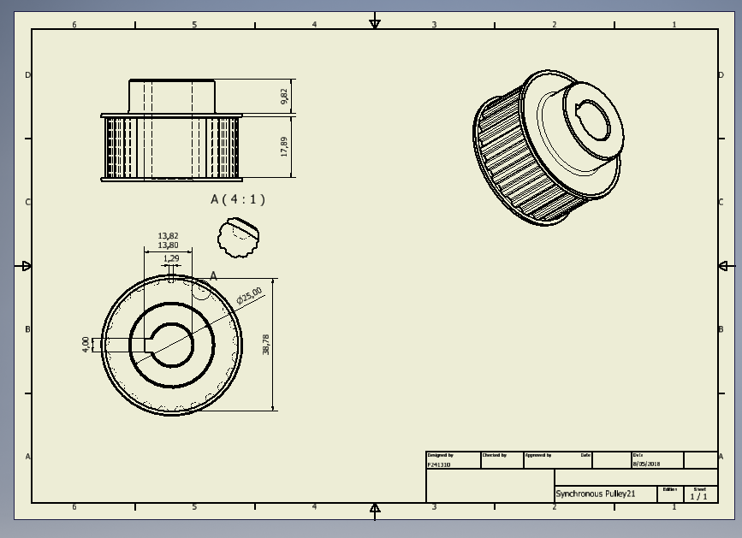

FIGURE J

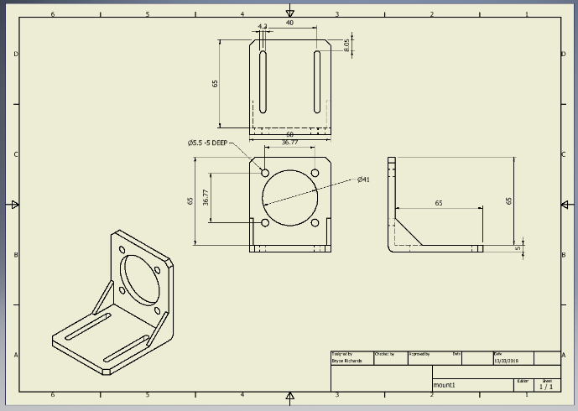

FIGURE K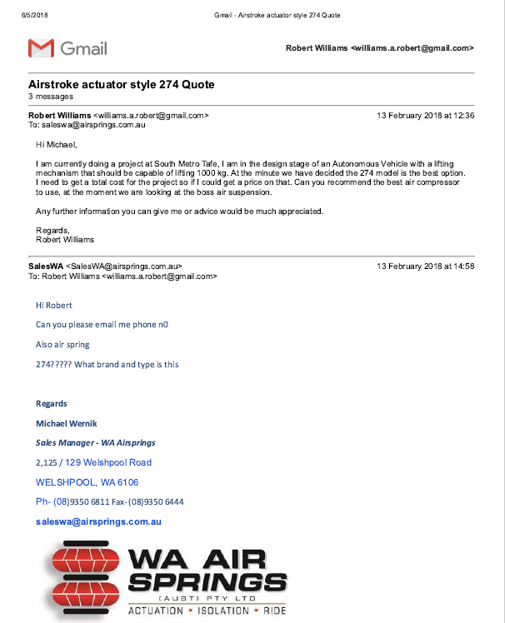

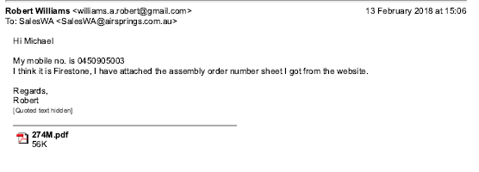

FIGURE L

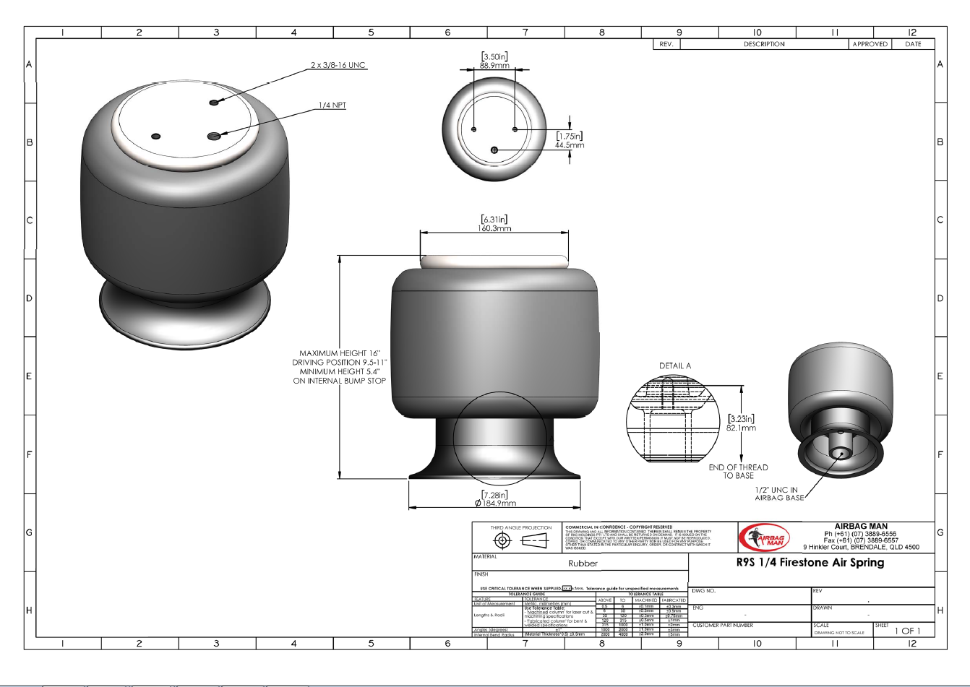

FIGURE M

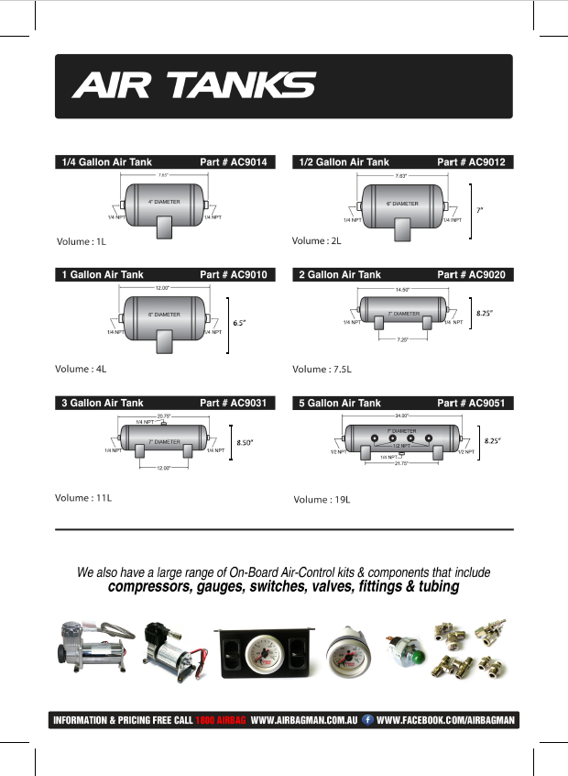

FIGURE N

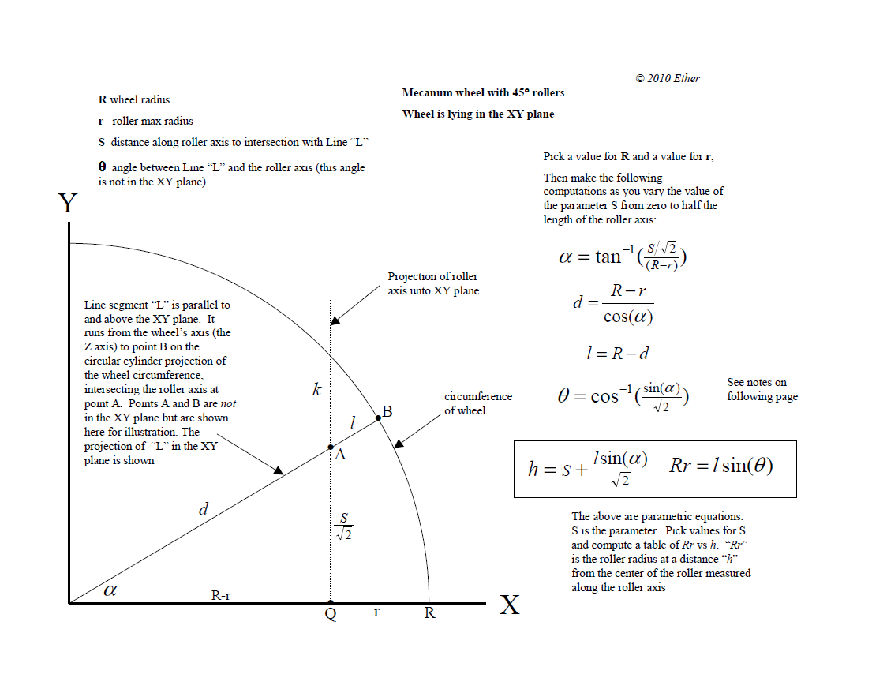

FIGURE O

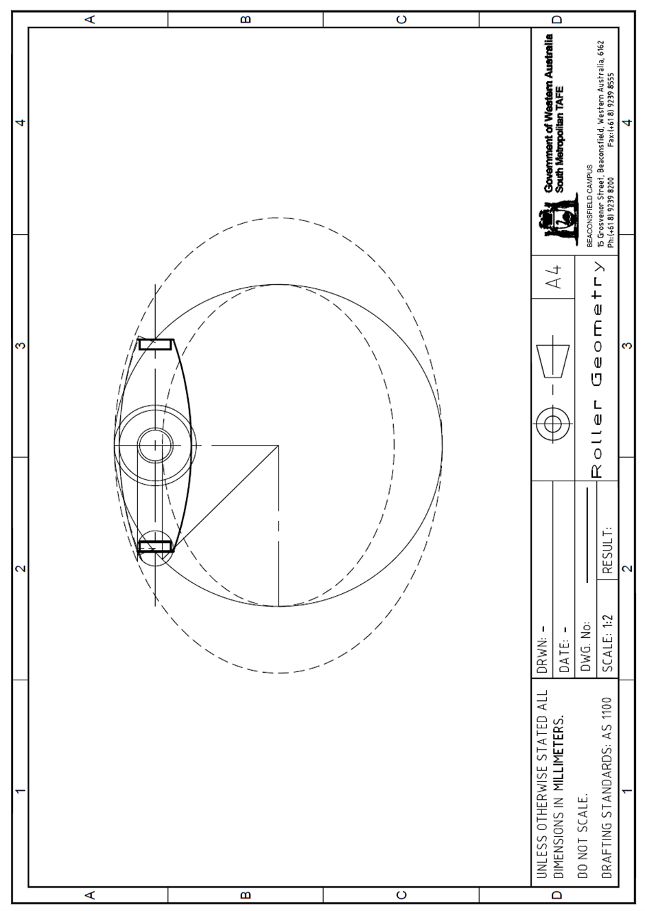

FIGURE P

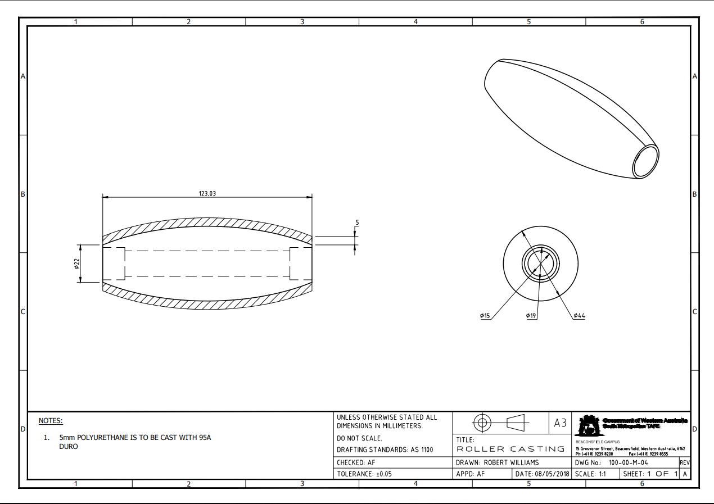

FIGURE Q

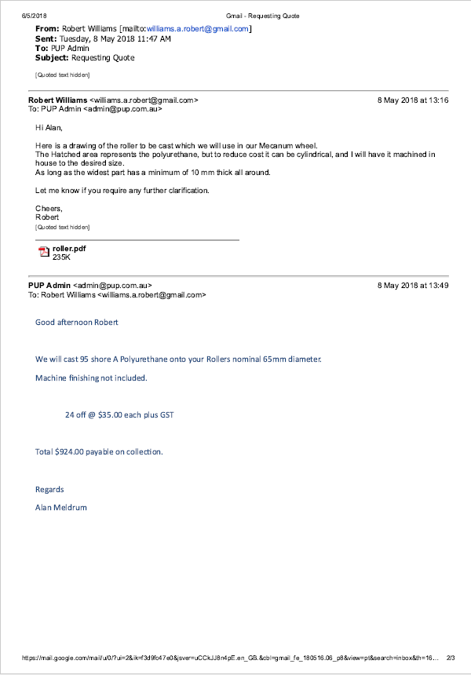

FIGURE R

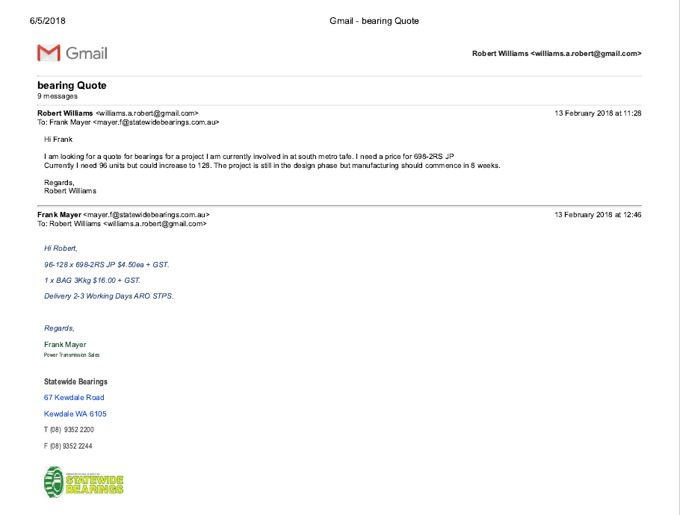

FIGURE S

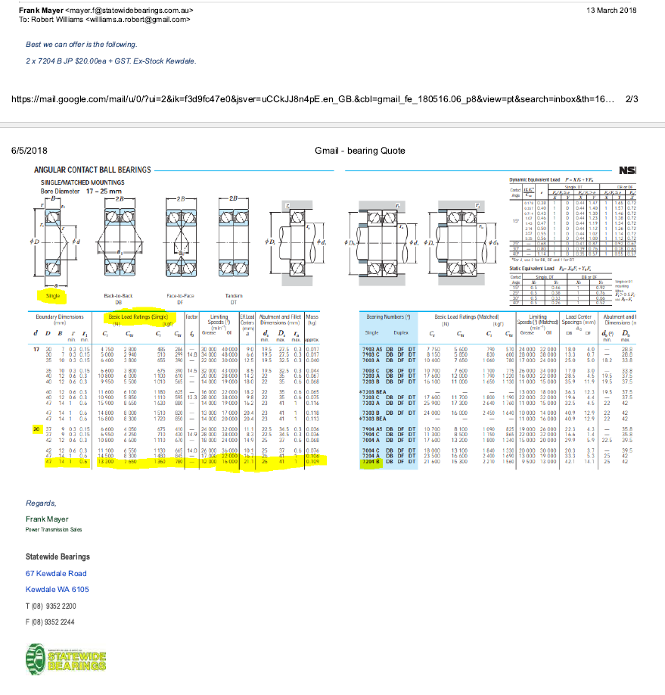

FIGURE T



**Sales Quote**

Naismith Engineering & Manufacturing Co. Pty Ltd 149 Heidelberg Rd, Northcote VIC 3070 Australia PO Box 261, Northcote VIC 3070 Australia

Ph: 03 9489 9811 Fax: 03 9482 1474

[www.naismith.com.au](http://www.naismith.com.au/) A.B.N. 25 004 284 388

|  |  |  |
| --- | --- | --- |
| To: | **Cash Sale Account** Cust Phone No:  Cust Fax No:  Australia | Date: 27/04/18  Account Code: CASHSALE Quote No: Q108624  Page No: 1 of 1 |
| Attention: From: | Cyprian Sino  Pinal | |
| 10% G.S.T. MUST BE ADDED TO THESE PRICES | | |
| **A$ List**  **Item Description Quantity Unit Price Disc% Extension** | | |

16 X T5-340 T5-340 Metric Timing Belt (68)

`

|  |  |  |  |  |  |
| --- | --- | --- | --- | --- | --- |
| 25-T5-16 | 25-T5-16F Timing Pulley Pilot Bore 27T5/25 | 2.00 | EACH | 13.60 | $27.20 |
| REBORE | Bore 14mm H7 with 5mm x 2.3mm Key-way + G/S | 1.00 | EACH | 41.90 | $41.90 |
| REBORE | Bore12mm H7 with 4mm x 1.8mm Key-Way + G/S | 1.00 | EACH | 41.90 | $41.90 |
| -340-T5-16 | 340-T5-16 Metric Timing Belt (68) | 1.00 | EACH | 36.10 | $36.10 |
|  | This belt is cut from a sleeve and is not returnable. |  |  |  |  |

All above Ex-Stock Melbourne.

Allow approx. 2-3 working days for Machining.

Bank Details

**IMPORTANT NOTICE**

All prices are subject to change without notice. Prices for goods imported against orders are subject to change due to exchange rate variations

|  |  |
| --- | --- |
| Sub Total Exc. G.S.T. | $147.10 |
| 10% G.S.T. | $14.71 |
| **Quotation Total** | **AUD $161.81** |

For Direct deposits and electronic transfer Westpac

BSB - 033048

Account No. - 612285

Terms: Cash

This Quote will automatically expire 30 days from the date issued.

This quotation must be read in conjunction with our General Terms and Conditions of Sale

FIGURE U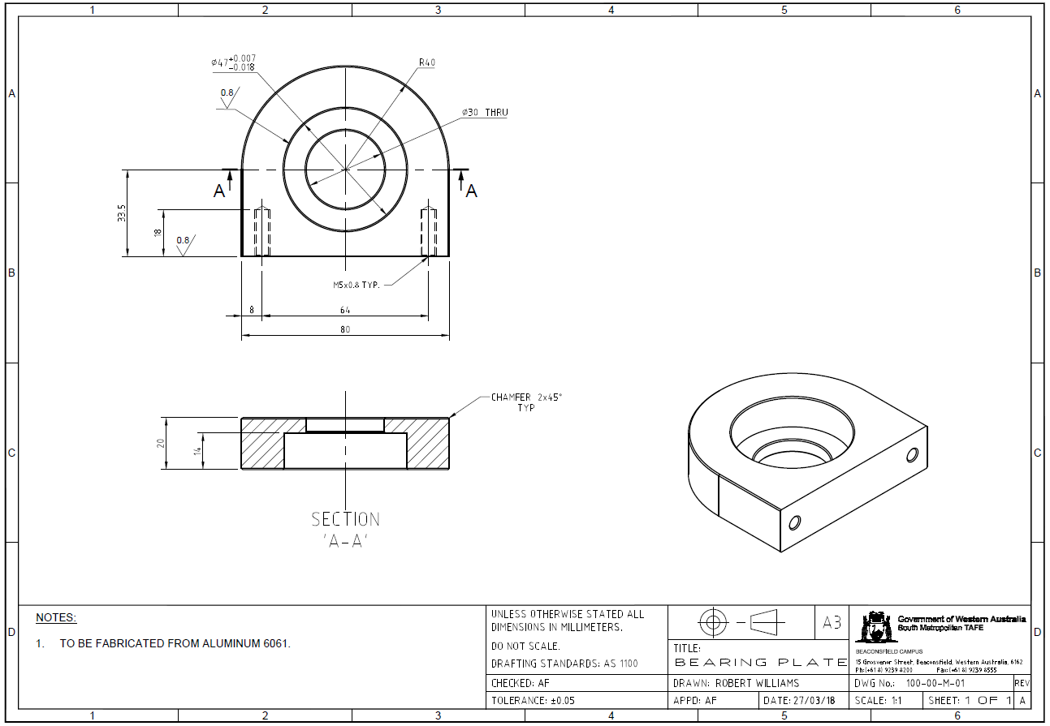

FIGURE V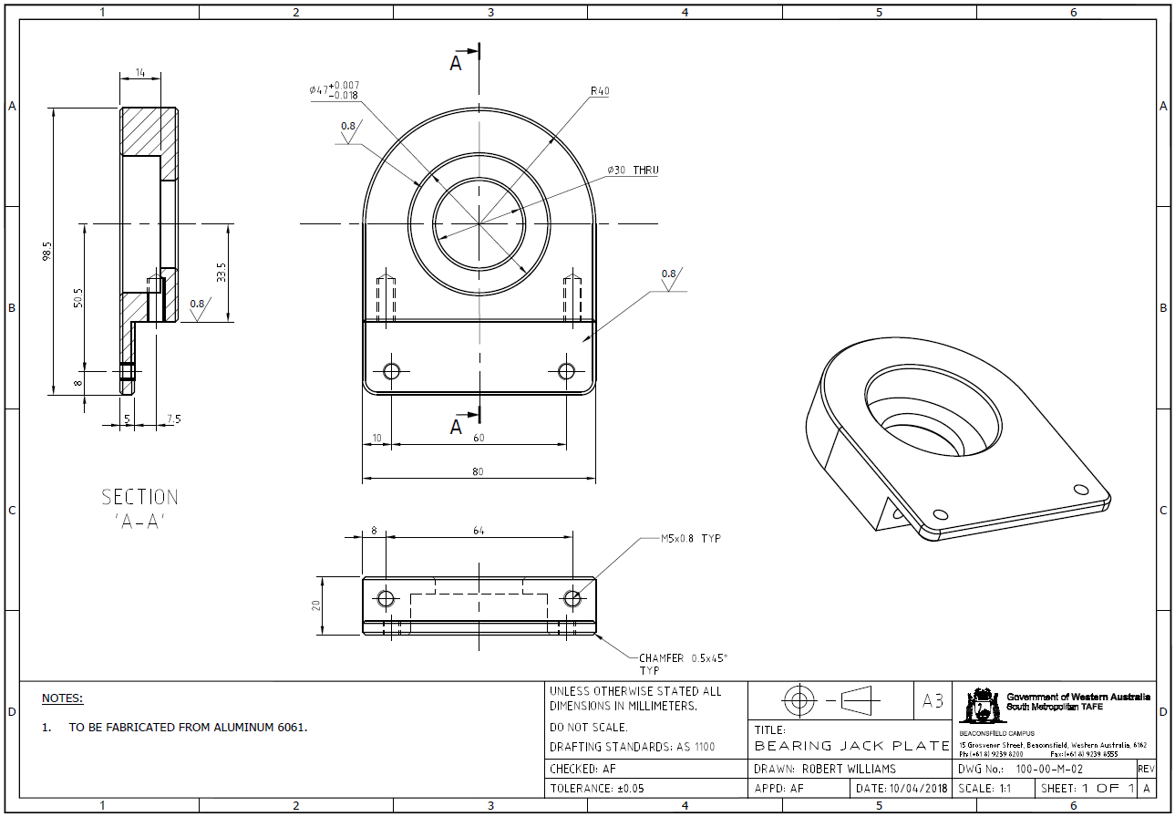

FIGURE W

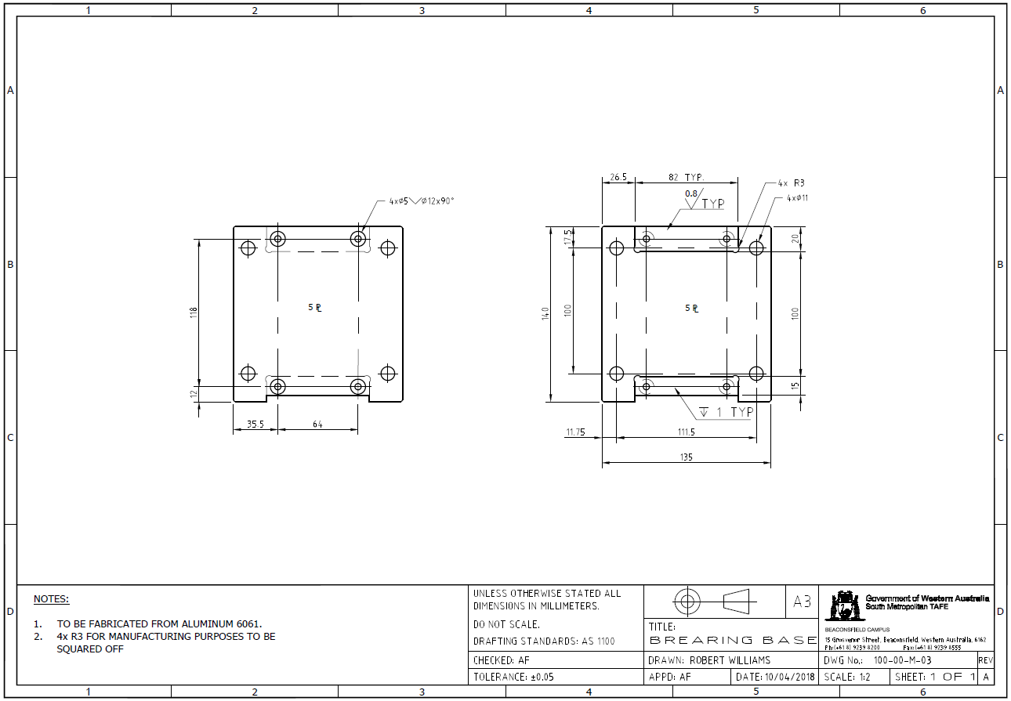

1. EEP. (2016, January 11). 9 Reasons For Automation Of Manufacturing Processes | EEP. Retrieved June 19, 2018, from <http://electrical-engineering-portal.com/9-reasons-for-automation-of-manufacturing-processes>
2. Material & Work-in-Process Movement. (2009, March 18). Retrieved from <http://www.jbtc.com/automated-systems/products-and-applications/applications/material-and-work-in-process-movement>
3. Automatic Material Transport Agv Robot Price - Buy Agv Robot Price,Automatic Material Transport,Material Transport Agv Product on Alibaba.com. (n.d.). Retrieved June 19, 2018, from <https://www.alibaba.com/product-detail/Automatic-material-transport-agv-robot-price_60719093453.html?spm=a2700.7724857.main07.80.322f1943C21lp8>
4. Maps.finance.gov.au. (n.d.). [online] Available at: https://maps.finance.gov.au/sites/default/files/whs_risk_assessment_201802.pdf [Accessed 18 Aug. 2017].
5. Chiefdelphi.com. (n.d.). [online] Available at: http://www.chiefdelphi.com/media/papers/download/2749 [Accessed 25 Sep. 2017].
6. Interlloy.com.au. (n.d.). 6061 Aluminium | Interlloy | Engineering Steels + Alloys. [online] Available at: http://www.interlloy.com.au/our-products/aluminium/6061-aluminium/ [Accessed 24 Jun. 2018].
7. Plasticsintl.com. (n.d.). Hardness Scale - Durometer Comparisons of Materials | Plastics International. [online] Available at: http://www.plasticsintl.com/polyhardness.htm [Accessed 24 Jun. 2018].
8. Richards, B. (2017). *Scope Statement – Mecanum AGV Project: Project Description*
9. Power Jacks. (n. d.). E-Series Powerjacks: Metric Machine Screw Jack
10. Richards, B. (2018). ScrewJackQuote: Final Response
11. Ruland Couplings. (n. d.). MCLX /MSPX MCLC/MSPC
12. T.E.A. Transmissions. (2010). Ketterer Worm Gear. Retrieved June 19, 2018, from <https://www.tea.net.au/Product-Category-Modules/Specific_Product/product/Ketterer-Worm-Gear-/prodid/184/cid/19>
13. KHK Gears. (n. d.). PBX: Miniature Bevel Gearboxes. Retrieved June 19, 2018, from <https://khkgears.net/pdf/pbx.pdf>
14. TSINY. (n. d.). TS-58GZ868. Retrieved June 19, 2018, from [www.tsinymotor.com/uploads/soft/140520/1-1405201J956.pdf](http://www.tsinymotor.com/uploads/soft/140520/1-1405201J956.pdf)
15. <http://ph.parker.com/au/en/economic-inline-planetary-gearboxes-ptn-series/ptn060-008s7-m060-140-000>.
16. <https://oceancontrols.com.au/MOT-126.html>

    <http://ph.parker.com/au/en/economic-inline-planetary-gearboxes-ptn-series/ptn060-008s7-m060-140-000>

    <https://oceancontrols.com.au/SMC-007.html>

    <https://www.pololu.com/product/2258>
17. Magnetic Guide Sensor,: https://www.roboteq.com/index.php/component/virtuemart/320/mgs1600cgy-magnetic-sensor-with-gyroscope-detail?Itemid=972
18. Magnetic Tape, Retrieved from: <https://www.aliexpress.com/item/Self-adhesive-Virtual-Protective-wall-for-Neato-Xiaomi-VR200-Lake-roborock-Haier-LG-Navigation-Magnetic-Flexible/32815546131.html?spm=2114.10010108.1000023.1.6cb02a9fCSRnzP>
19. Motor Controllers, Retrieved From:<https://www.aliexpress.com/item/1pcs-New-Dual-H-Bridge-DC-Stepper-Motor-Drive-Controller-Board-Module-L298N-MOTOR-DRIVER/32840272617.html?spm=2114.search0104.3.43.7c294774HEMeVu&ws_ab_test=searchweb0_0,searchweb201602_5_10152_10065_10151_10344_10068_10130_5722918_10342_5722818_10547_10343_10340_10548_10341_5722618_10696_10084_10083_10618_10307_5722718_10131_10132_10133_10059_306_100031_10103_5722518_10624_10623_10622_10621_10620,searchweb201603_31,ppcSwitch_5&algo_expid=d483ae9b-cd2e-44f8-9e3b-695d7e0a392d-6&algo_pvid=d483ae9b-cd2e-44f8-9e3b-695d7e0a392d&priceBeautifyAB=0>
20. Encoders, Retrieved form: https://www.aliexpress.com/item/400-pulses-Incremental-Optical-Rotary-Encoder-AB-Two-phase-5-24V-400-Pulses-Incremental-Optical-Rotary/32725917082.html?spm=2114.search0104.3.1.7d62e75cDS9LRJ&ws_ab_test=searchweb0_0,searchweb201602_5_10152_10065_10151_10344_10068_10130_5722918_10342_5722818_10547_10343_10340_10548_10341_5722618_10696_10084_10083_10618_10307_5722718_10131_10132_10133_10059_306_100031_10103_5722518_10624_10623_10622_10621_10620,searchweb201603_31,ppcSwitch_5&algo_expid=af4bc3cc-cc52-4773-8370-3e1a7f8ef6cf-0&algo_pvid=af4bc3cc-cc52-4773-8370-3e1a7f8ef6cf&priceBeautifyAB=0
21. "Best Buy Steel - Discount Steel". 2018. Bestbuysteel.Com.Au. http://bestbuysteel.com.au/php/webstore/ecom/.